**Database Development and Class Registration**

Betina Driggers

The University of Arizona Global Campus

CST 499: Capstone for Computer Software Technology

Dr. Charmelia Butler

October 13, 2025

**Database Development and Class Registration**

This paper outlines the development process of the Online Course Registration (OCR) system and the revisions made based upon feedback received. Building upon the application base – Master.php (landing page), Login.php, and Profile.php – the database schema was implemented using server-side endpoints and AJAX flows to allow for a connection to the database to complete a student profile registration, viewing currently registered courses, adding/dropping courses to semesters, and adding to a course waitlist if the course is currently full (MySQL, 2019). The code was aligned with the database to allow for secure access through the use of prepared statements and parameter binding (PHP, 2019). The thesis of this paper is that a normalized schema with foreign keys, coupled with parametrized queries and defined separation between the user interface (UI) and data points, creates a course registration workflow that is not only maintainable but also secure and verifiably correct.

**Revisions**

The following changes were completed for the OCR system. The changes made allowed for the system to be more secure, provide additional information, enhance user friendliness, and add additional functionality in regards to actions a student can complete within their profile.

* Profile Page: The Profile.php code behind was refactored to not only display the student’s basic information but also load the current schedule, waitlist, and available courses through the use of AJAX from Courses_API.php once the student has successfully logged in. The page renders server-side fallbacks, eliminating the need for JavaScript environments. Additionally, a “Total Credits” badge and term/semester selector were added, and require the API without needing to reload the page.

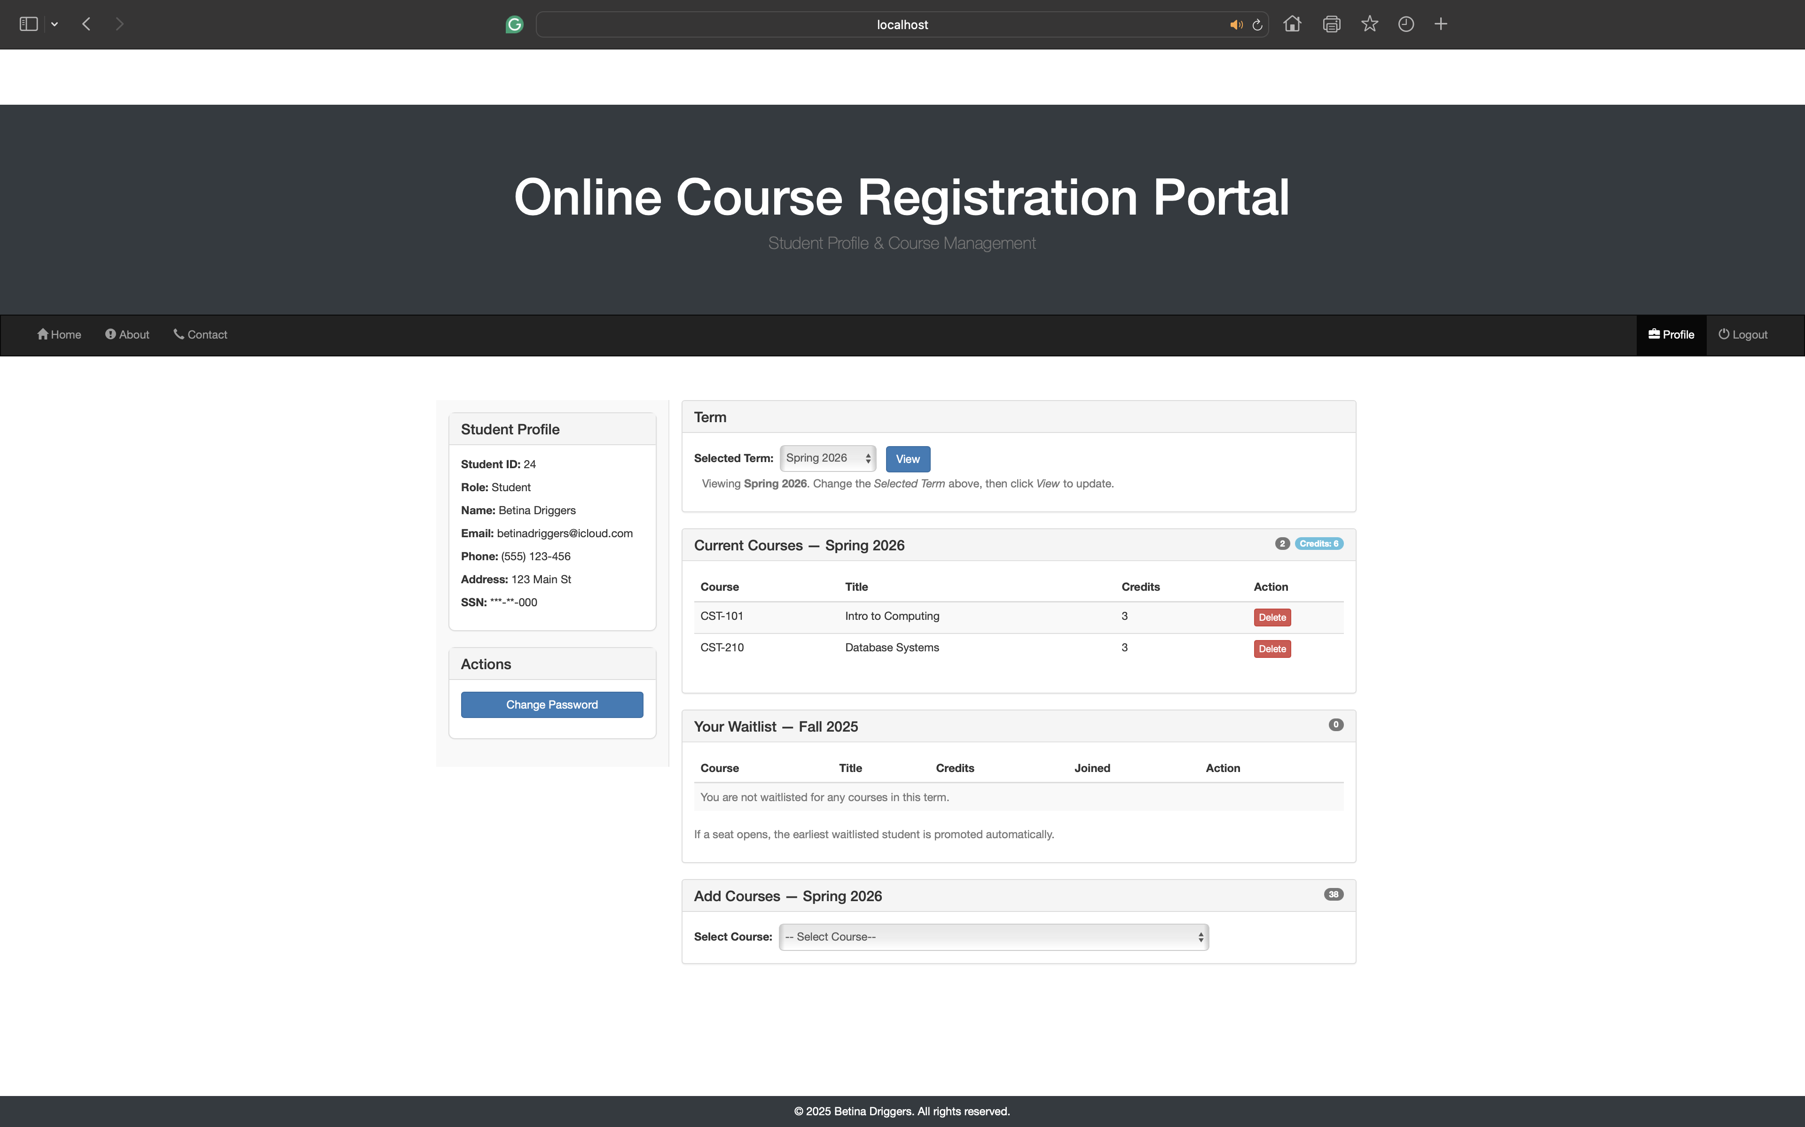

* Capacity Actions: A student is only able to add courses to a semester when seats are available, and the ability to join a class waitlist is only active when a class is at capacity. Therefore, the “Add Courses” panel only displays the “Register for Class” button when seats are available, and the “Join Waitlist” button is only displayed when the selected course is at capacity for the selected semester. This layout mimics a true registration page.

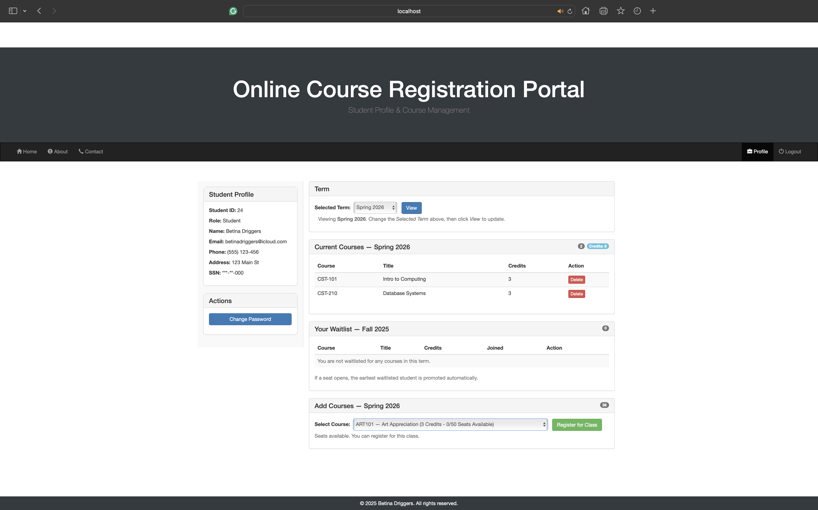

* Security: All Database interactions utilized prepared statements with bound parameters via mysqli, which eliminates the need for string-built SQL statements and reduces the risk of injection.

**My SQL Database**

The database schema uses InnoDB with foreign keys to preserve the referential integrity of the database. The database uses relational principles to reduce redundancy and any possible anomalies. The core tables of the database are tblUser (Lists students and admins who have successfully registered for a profile.), tblCourse (Lists all courses offered and current capacity of each course.), and tblEnrollment (Lists the students who have registered for courses and the term/semester in which the course was registered.)

**tblUser:**

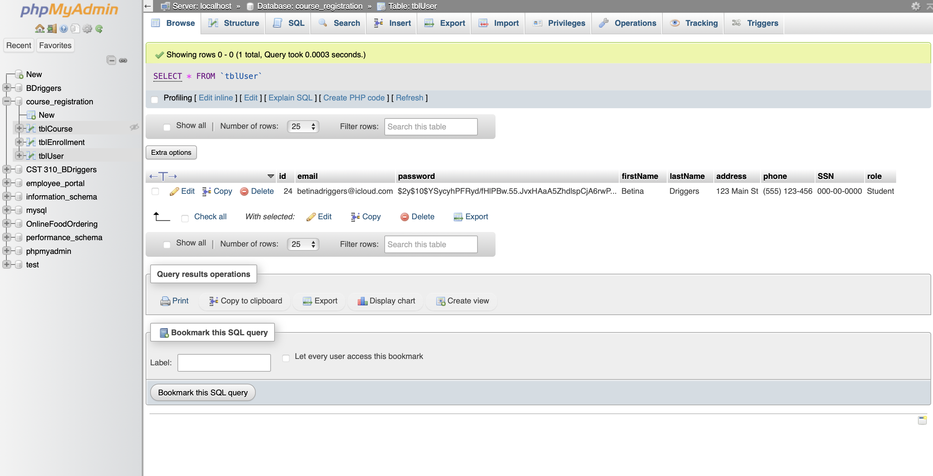

**tblCourse Creation:**

The SQL query below was used to create the table to list all offered courses. There is a check to ensure the table does not currently exist before creating it to reduce the risk of duplicate tables or errors. The table includes the use of a Primary Key(course_id) and indicates the values of the data required for each column within the table, which includes course code, course title, number of credits for each course, maximum capacity (seats available), and the date/time the course was created. Additionally, the maximum number of seats available per semester is set as well. This ensures that, as students enroll in the course within the same semester, the course is not offered if there are no available seats. Students can then request to join the waitlist in the event that a seat becomes available. The screenshot below provides the SQL query to create the Course table.

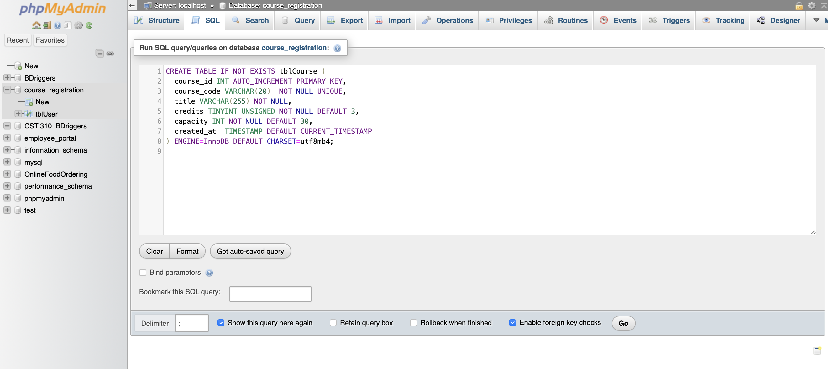

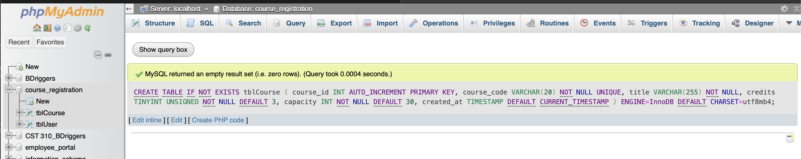

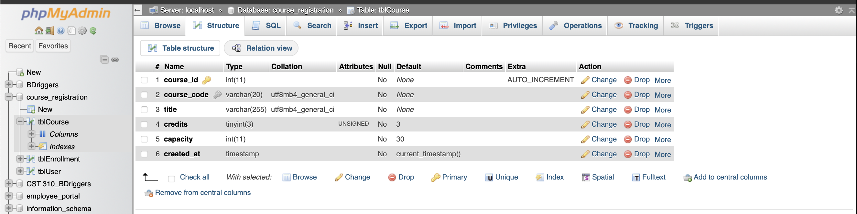

Once the course table has been created, courses are then added to the table through the use of the SQL statement shown in the screenshot below.

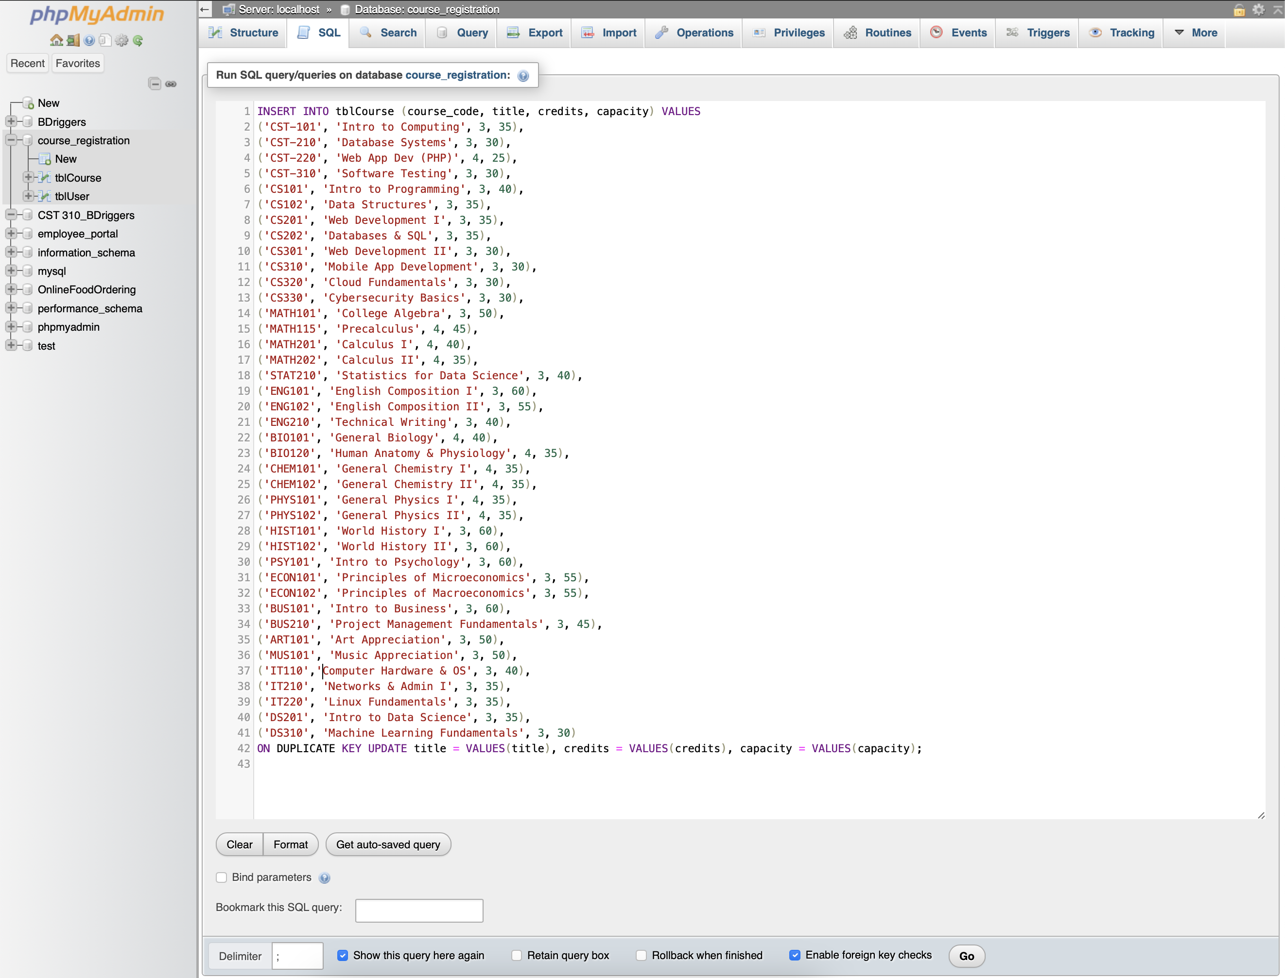

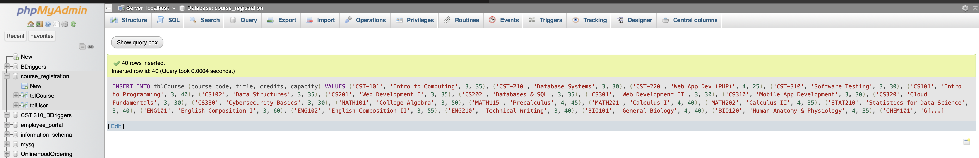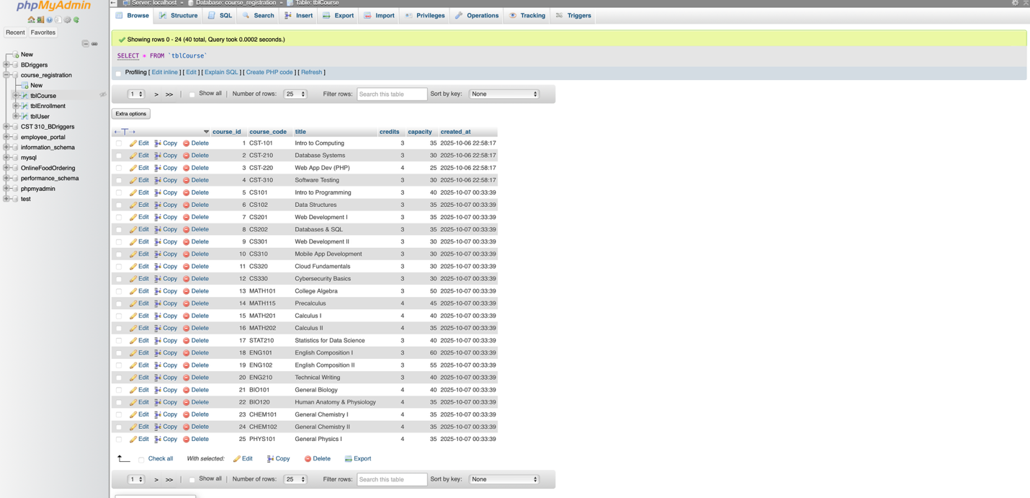

**tblEnrollment**:

After creating the table to house courses that are offered, the table to track course enrollment is created. This table houses the student ID, course ID, term/semester, enrollment states, and date/time the course was enrolled or dropped. Just as with tblCourse, this table contains a primary key, which is enrollment_id. The enrollment table references both the User and Course tables to ensure all of the proper data is displayed. For the User table, the Enrollment table references the user_id (the ID of the user attempting to enroll in the course), and for the Course table, the Enrollment table references the course_id. The screenshot below provides the SQL query utilized to create the Enrollment table.

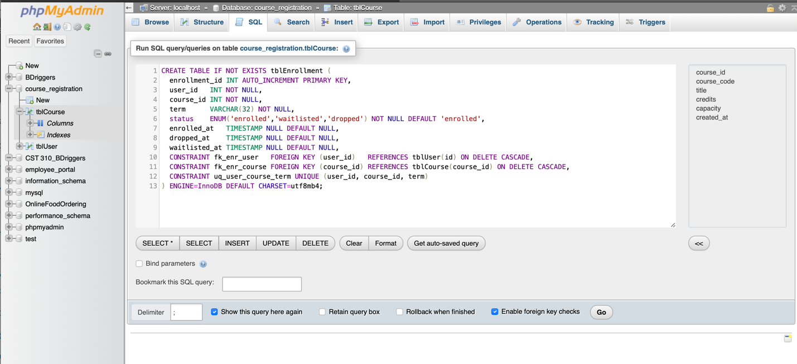

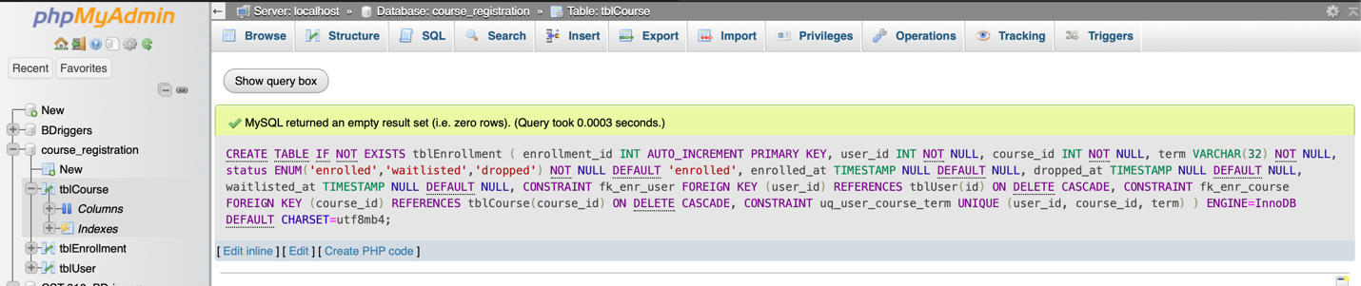

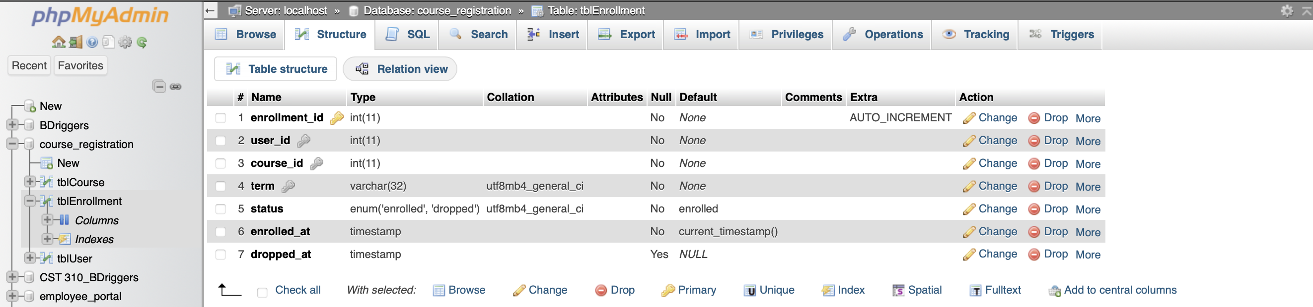

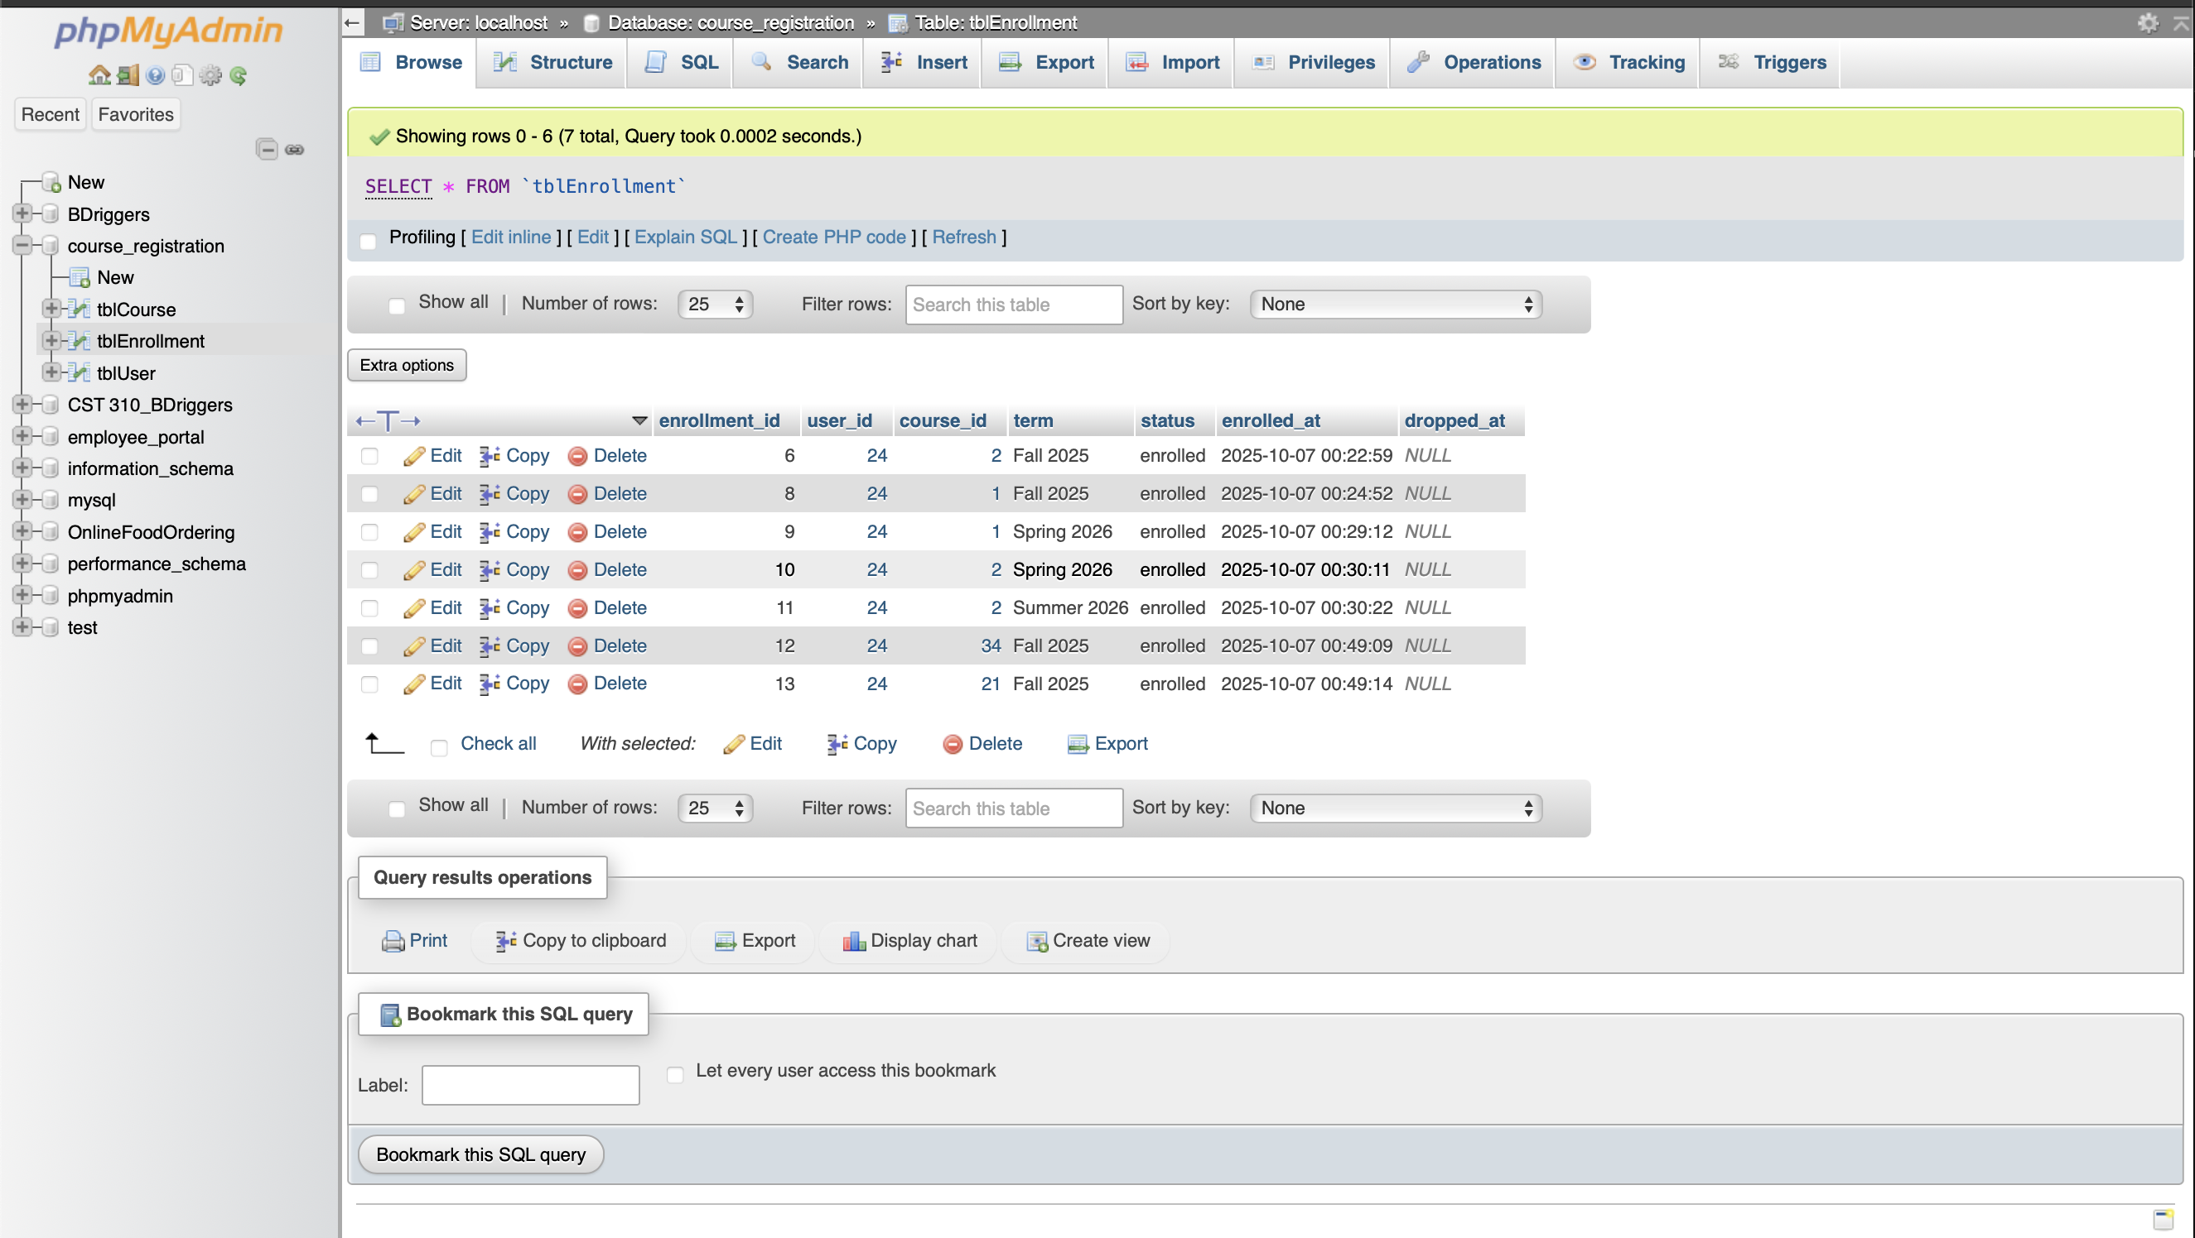

**Backend Database Connection**

The backend connection from the portal to the database is a lightweight connection that uses the CR_DB_Conn_Class.php script. This opens a single mysqli connection and is used in the code behind for pages including Login_Processn.php, Registration_Process.php, and Profile.php. Additionally, the database connection is used within Courses_API.php, as this handles the interactions to add, drop, or waitlist a course without needing to refresh the page with each interaction.   
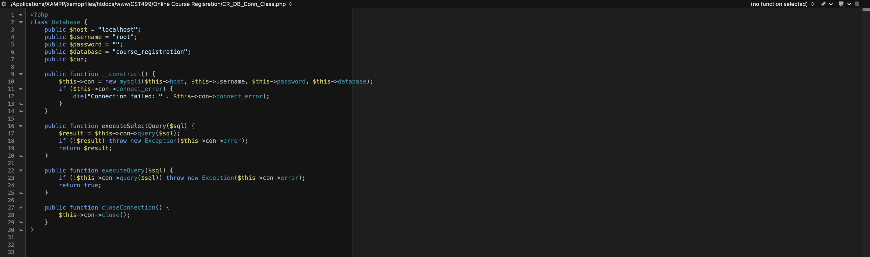

**Registration Page**

**Implemented Pages and Logic**

The following pages are implemented into the portal to not only provide the user with a pleasant user interface but also to make the process of registering or dropping courses a seamless task that can be done in one central location, which is the profile page that is displayed immediately after the user successfully logs into the portal.

* **Home (Master.php)**: Landing page for the Online Course Registration system/portal that provides navigation links to all available and working pages.

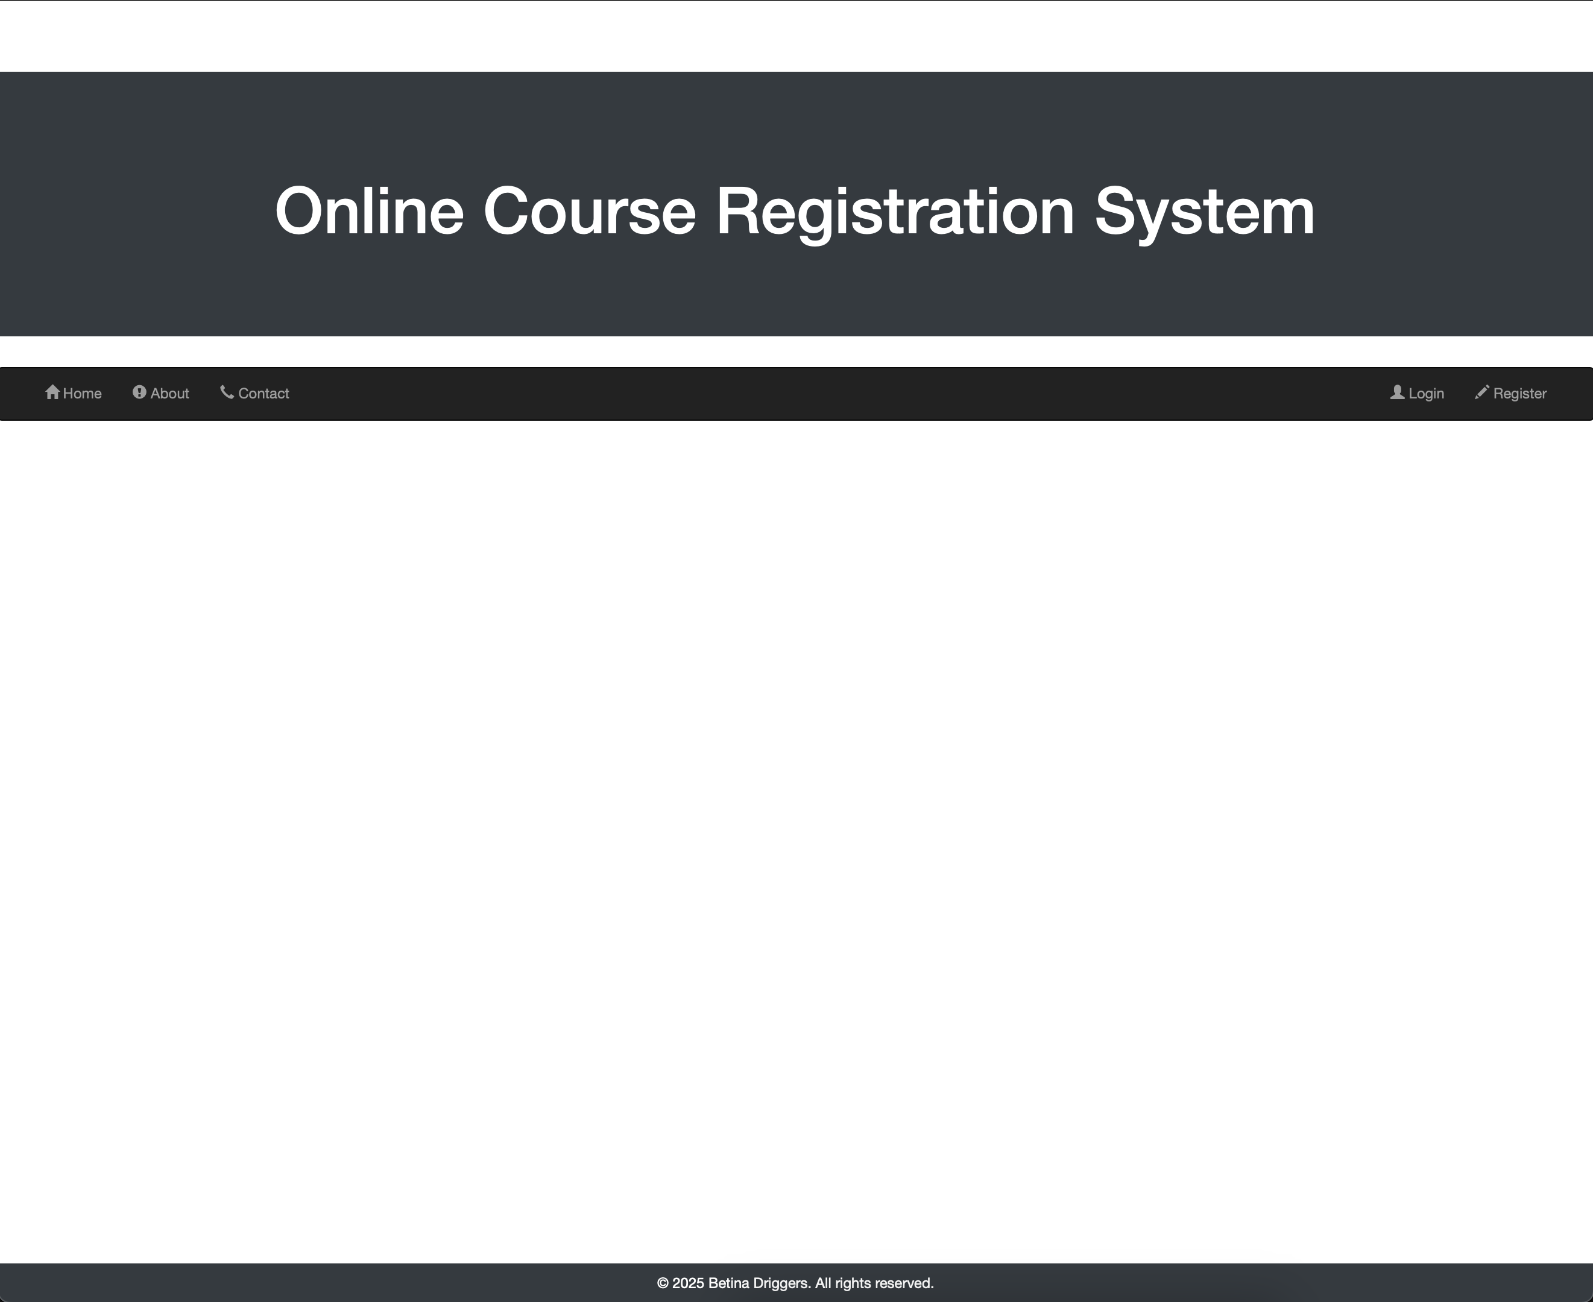

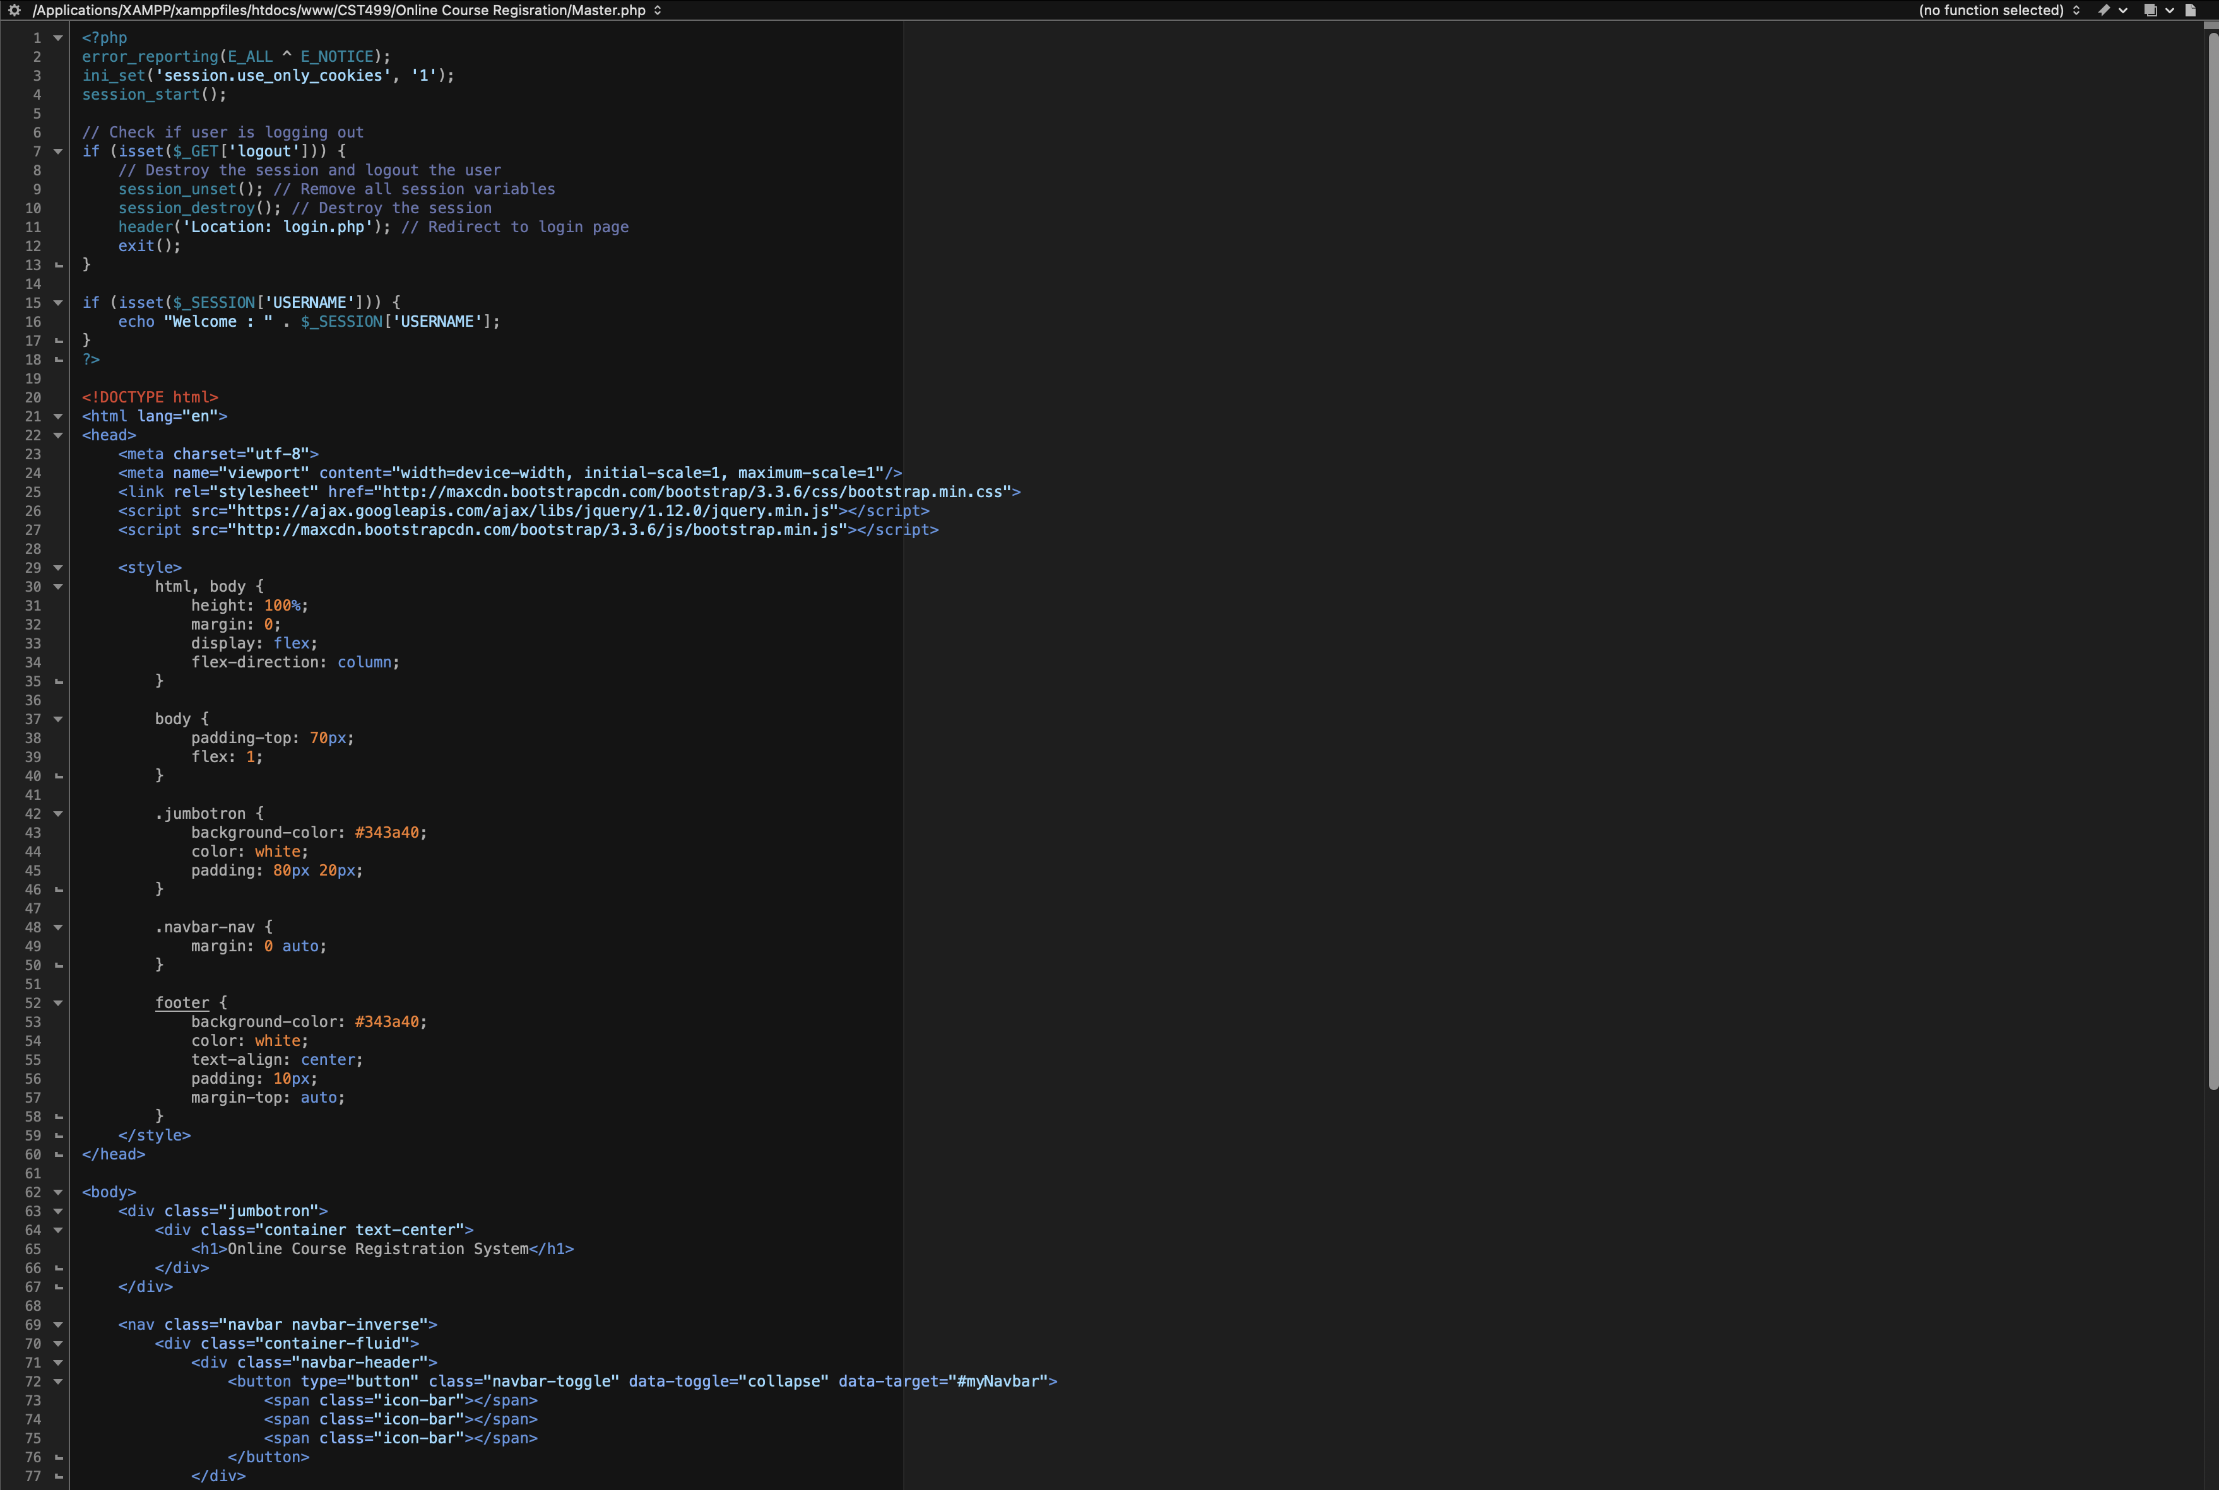  
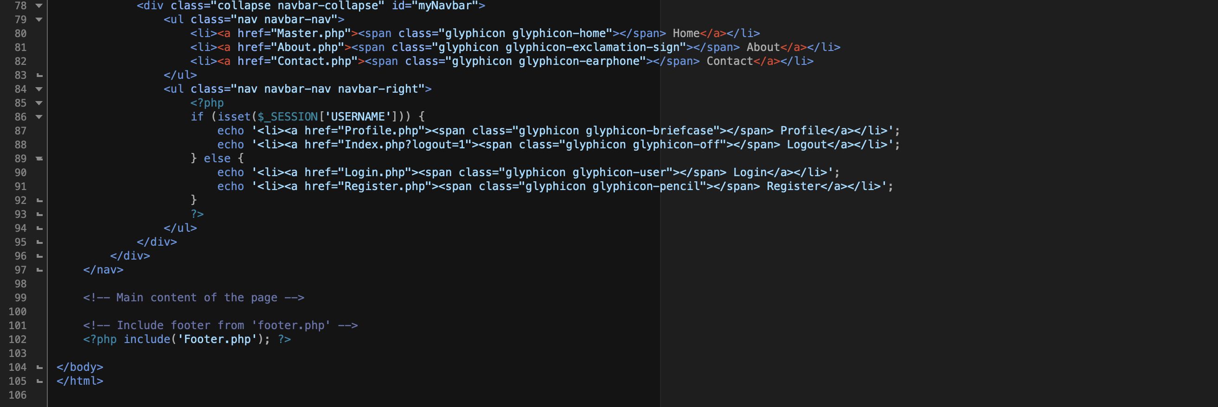

* **Register (Register.php):** Allows a new user to successfully register to use the portal by providing all required information and inserting the new user data in the tblUser through the use of CR_DB_Conn_Class.php code behind used within the Registration_Process.php code behind.

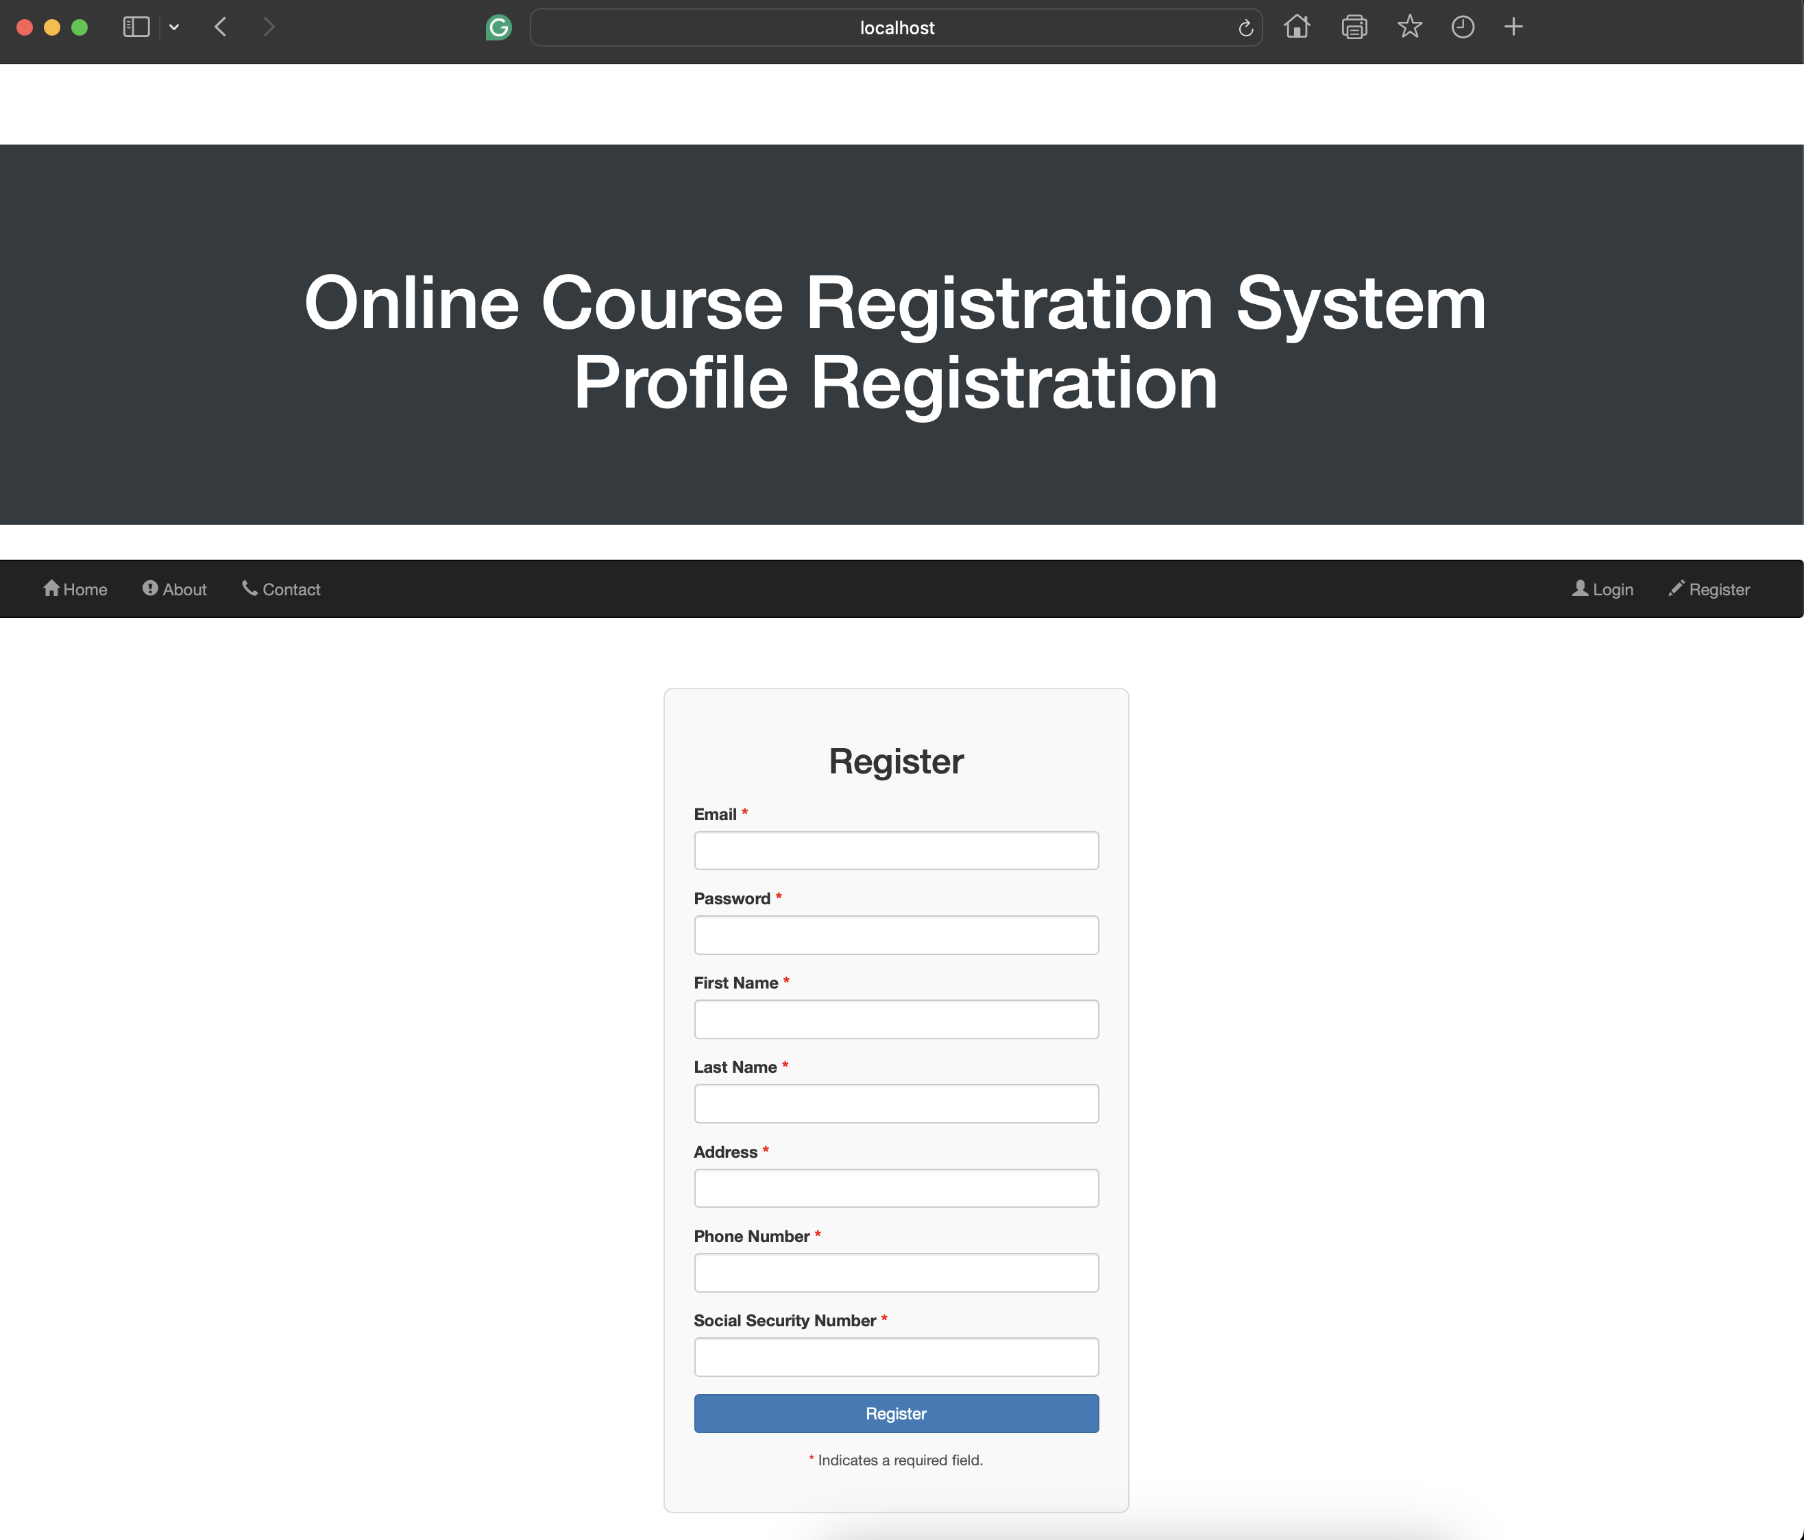

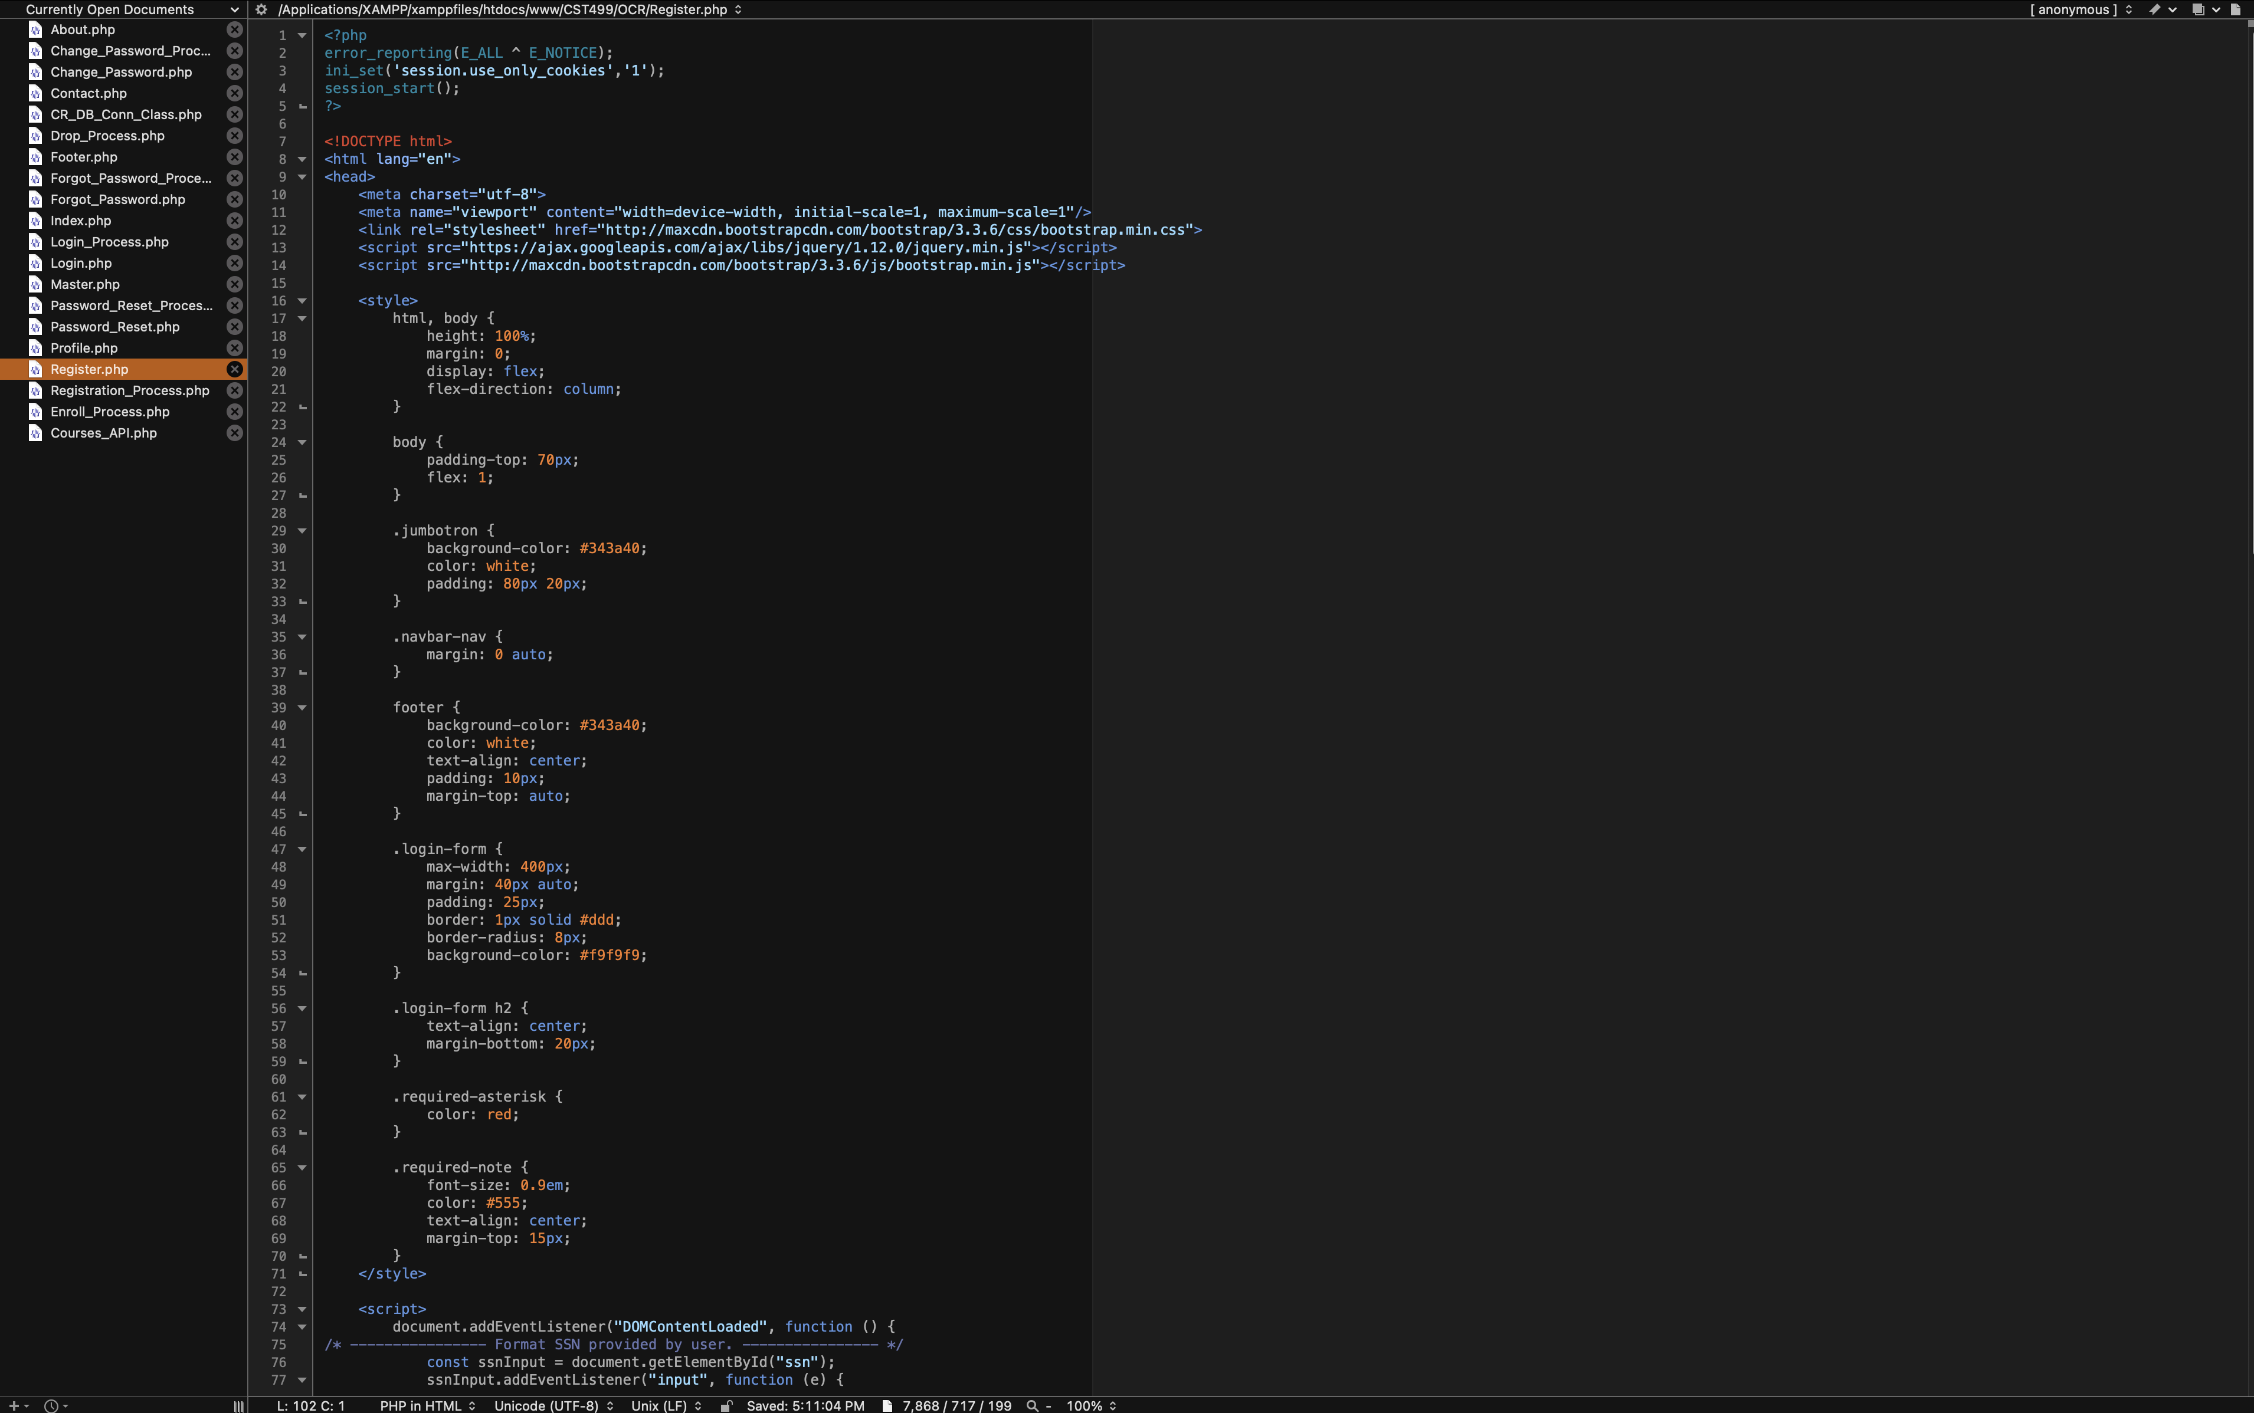

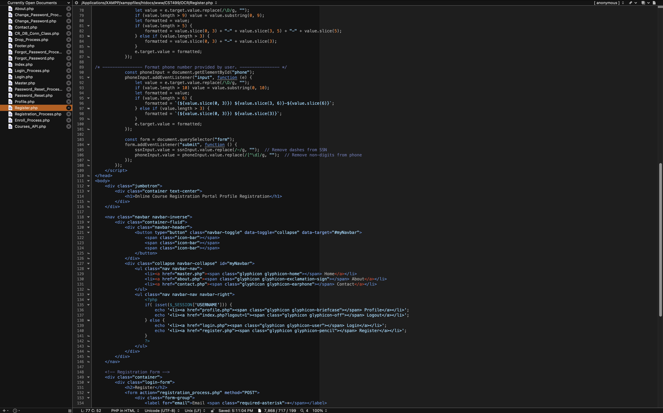

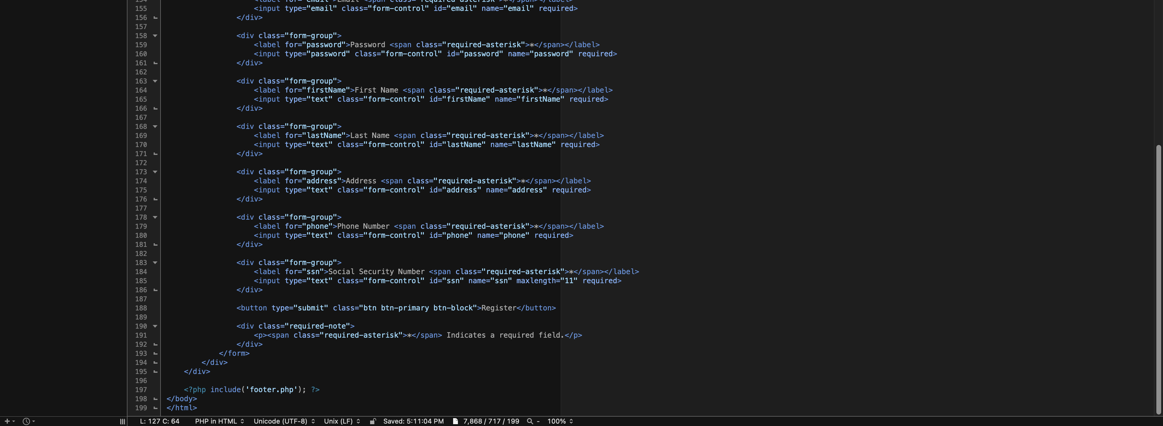

**Registration_Process.php**

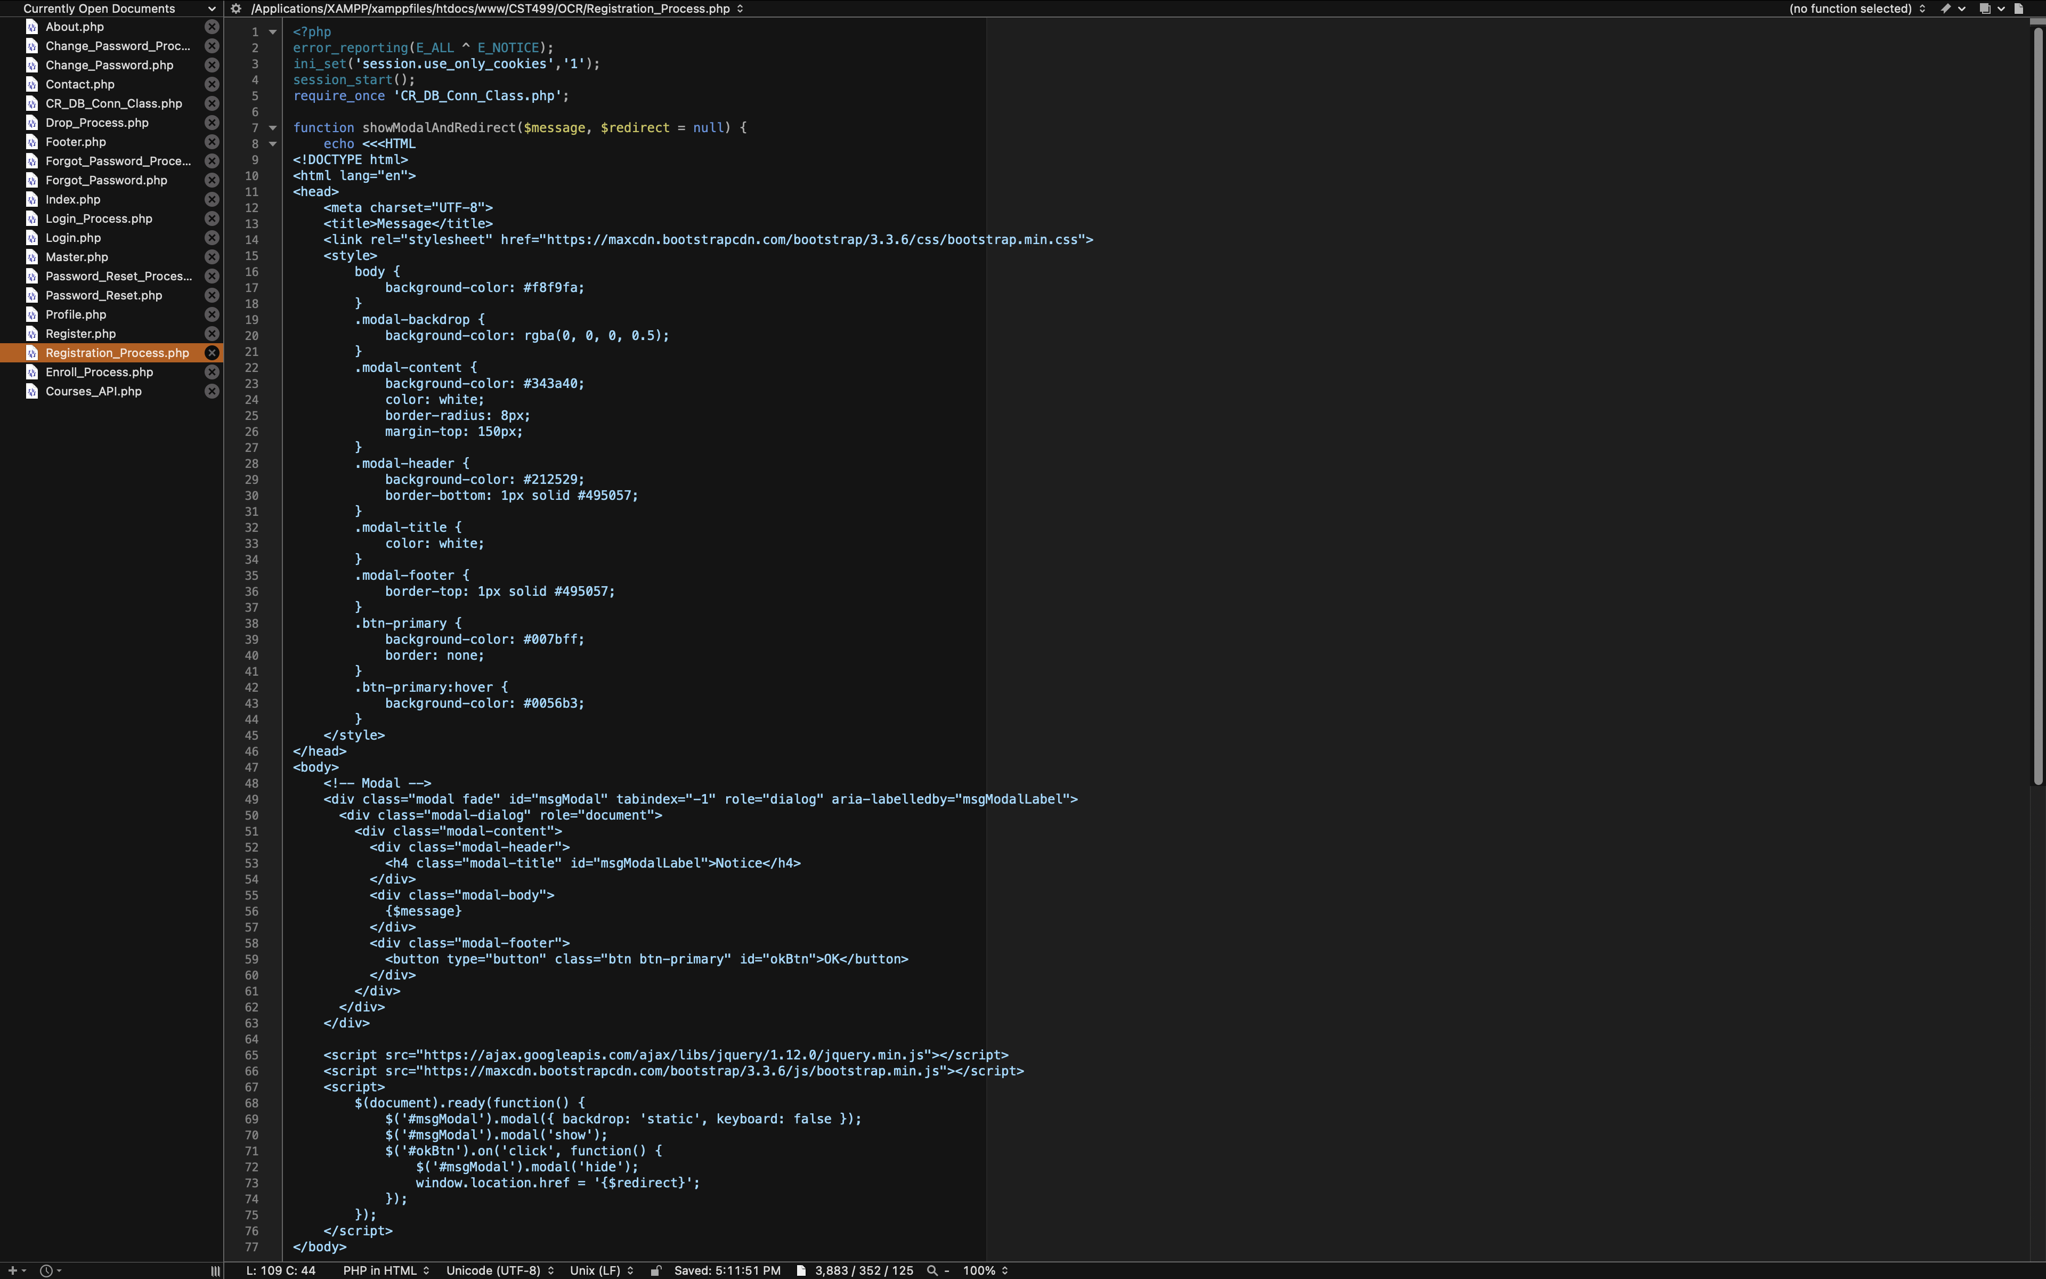

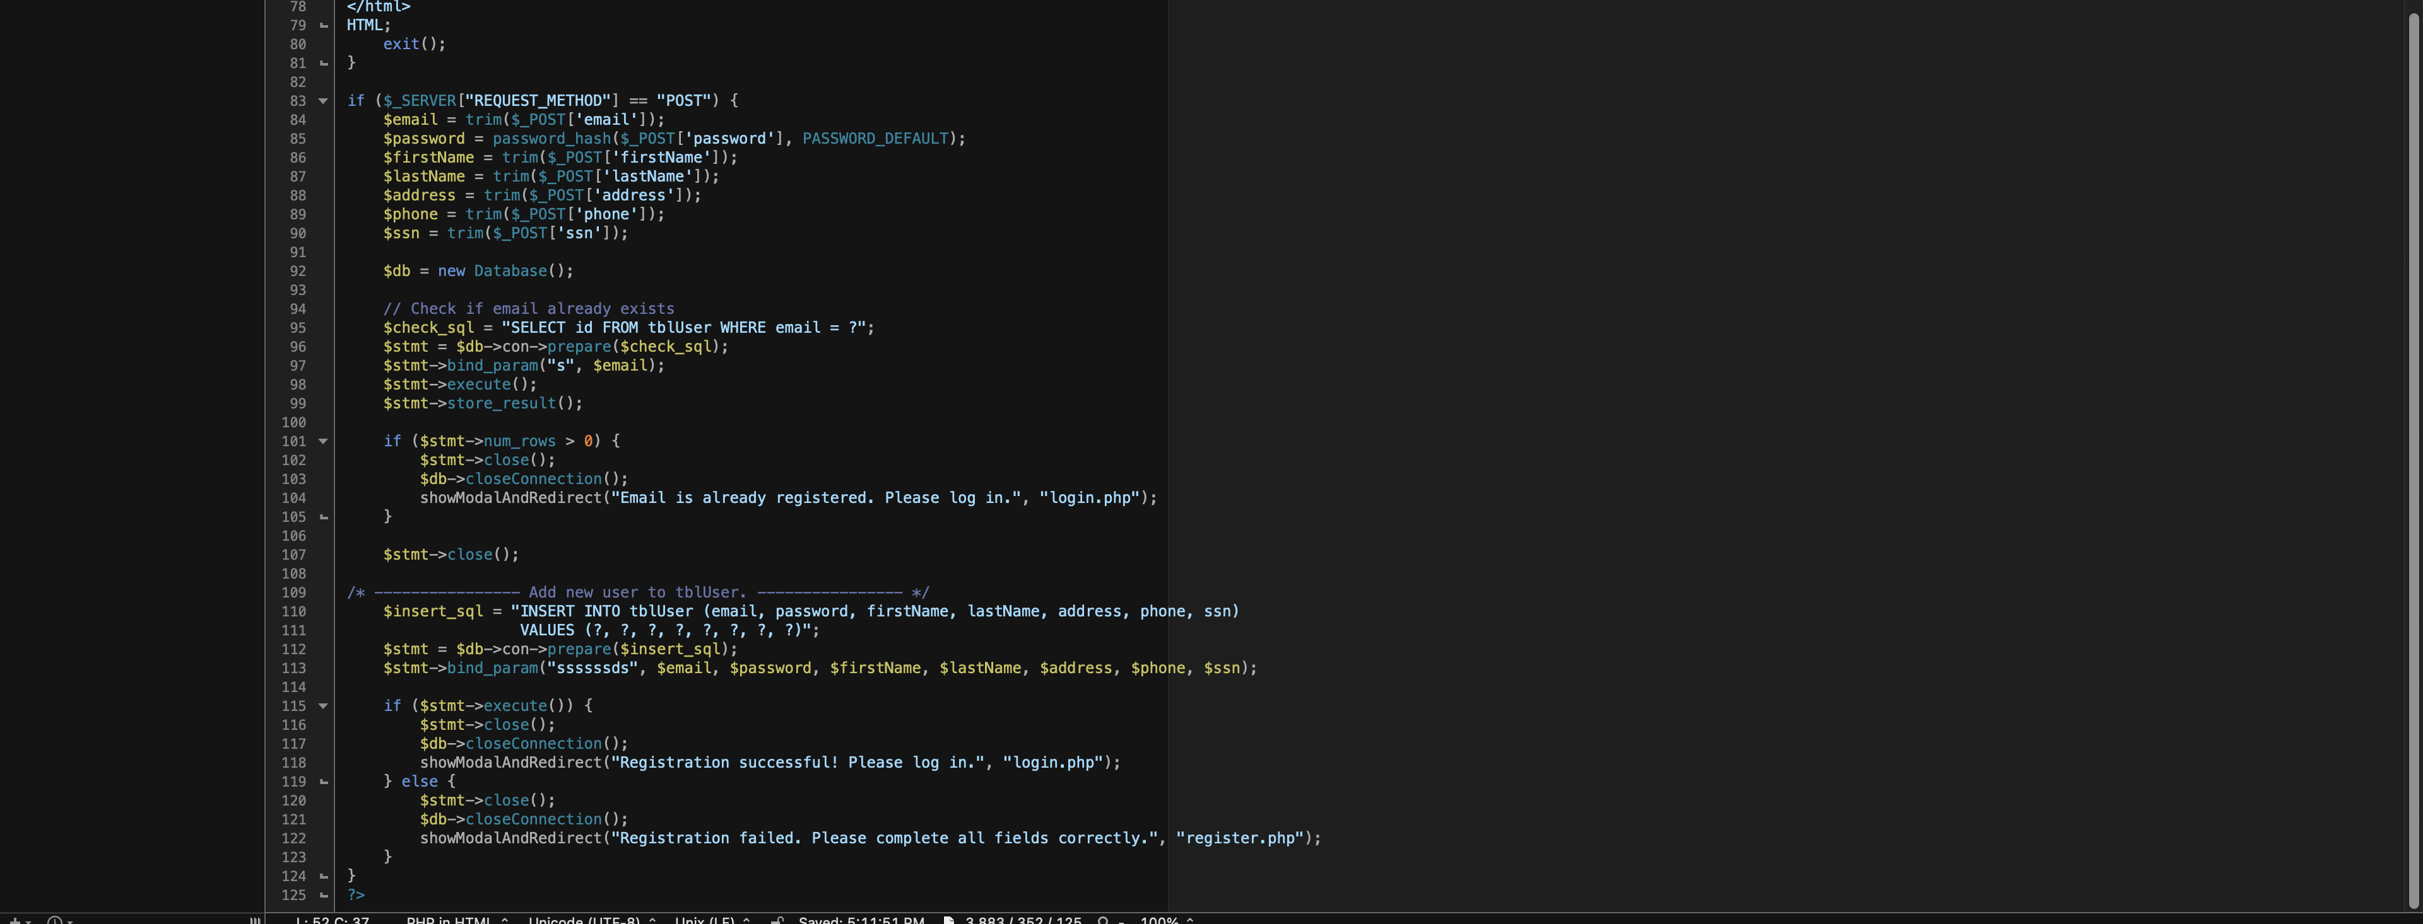

* **Login (Login.php)**: Allows the user to successfully log into the portal if a registered email address and password are provided. This information is confirmed via the Login_Process.php page using the CR_DB_Conn_Class.php script to query against the tblUser.

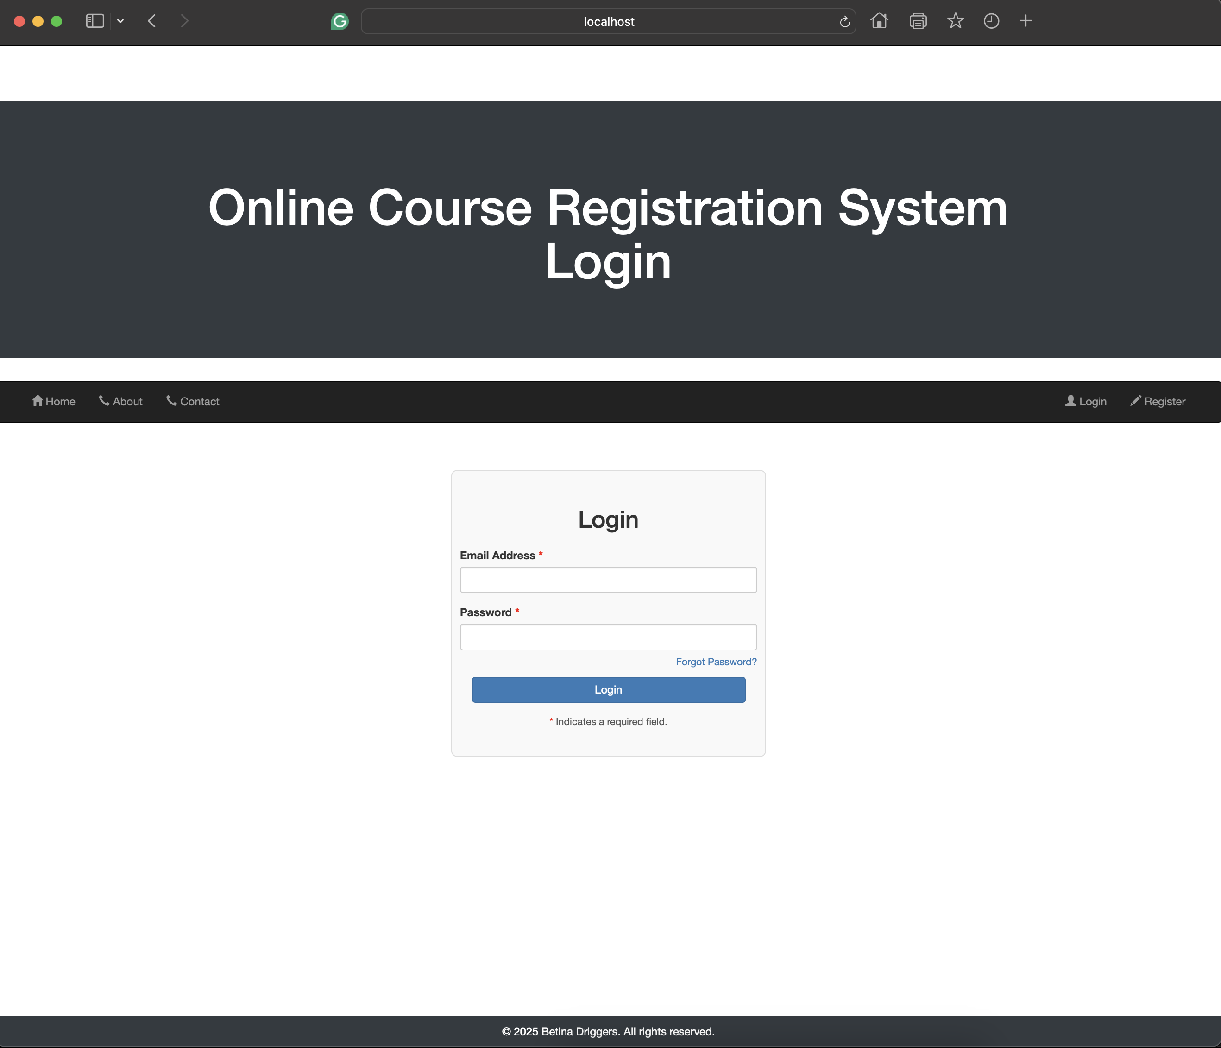

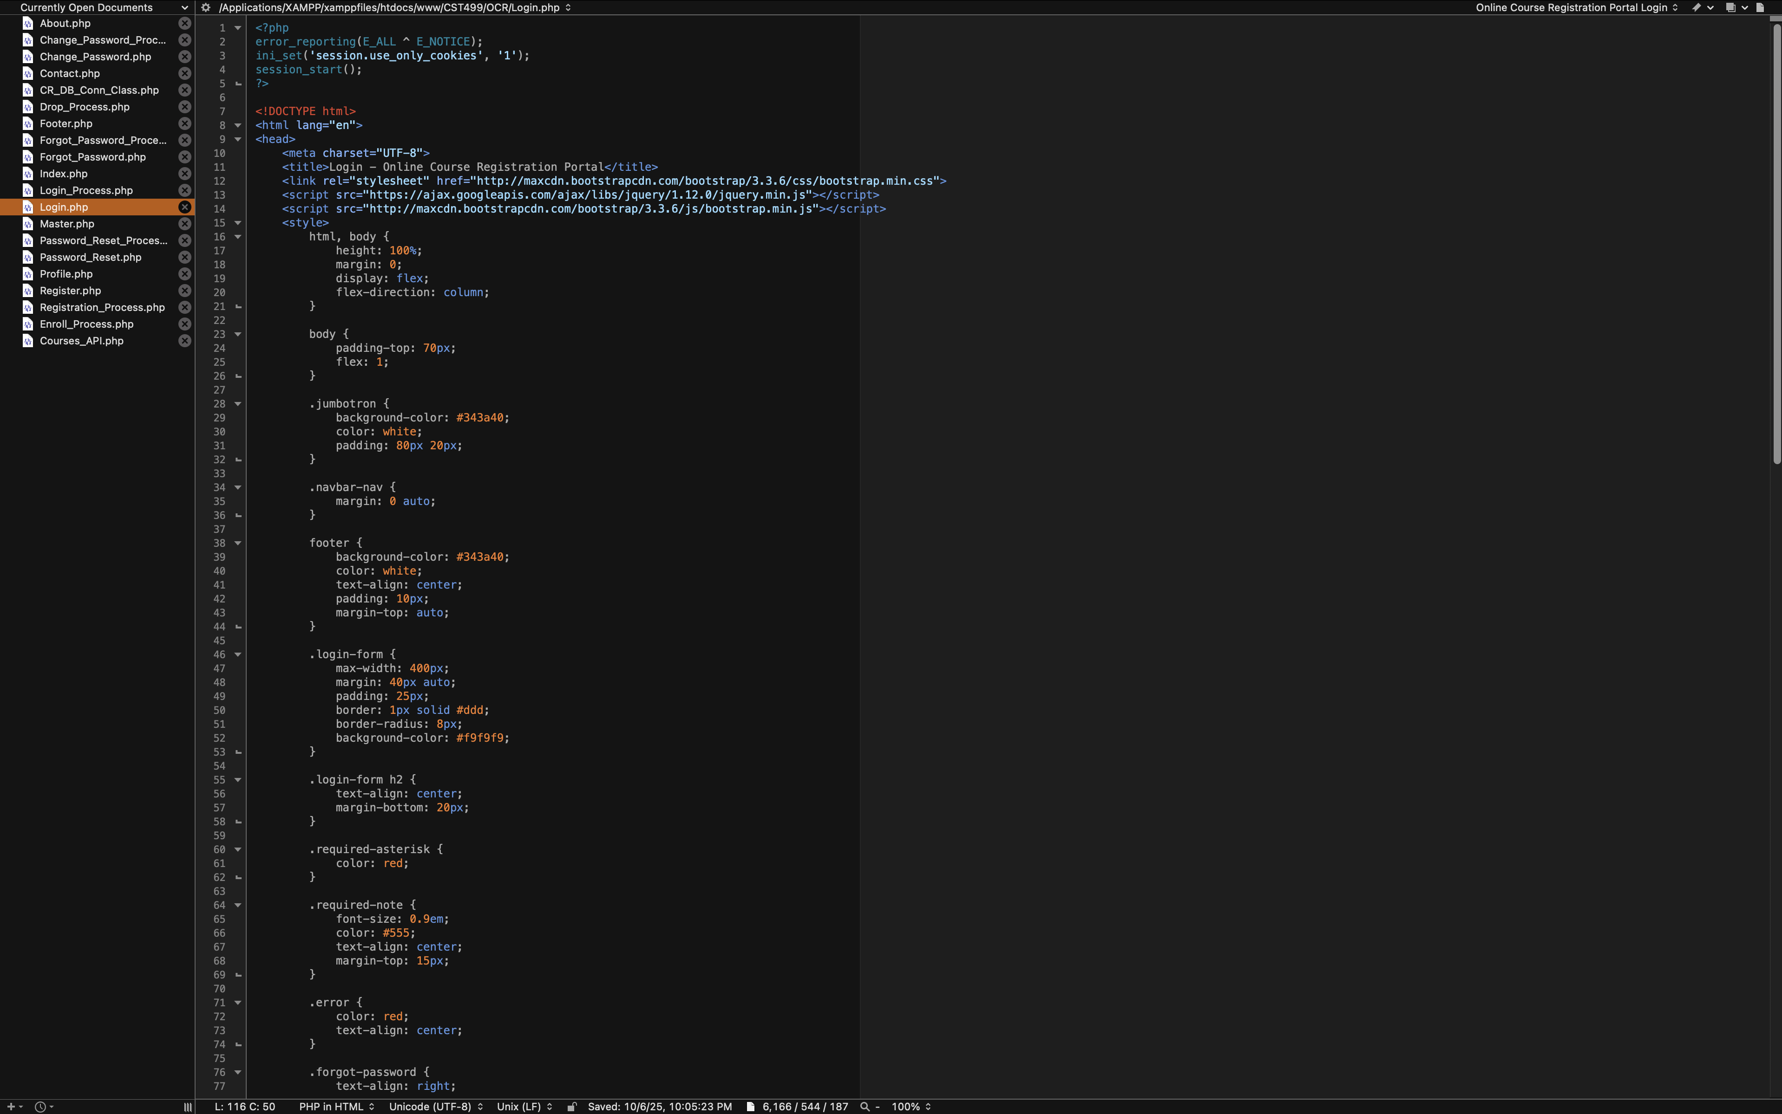

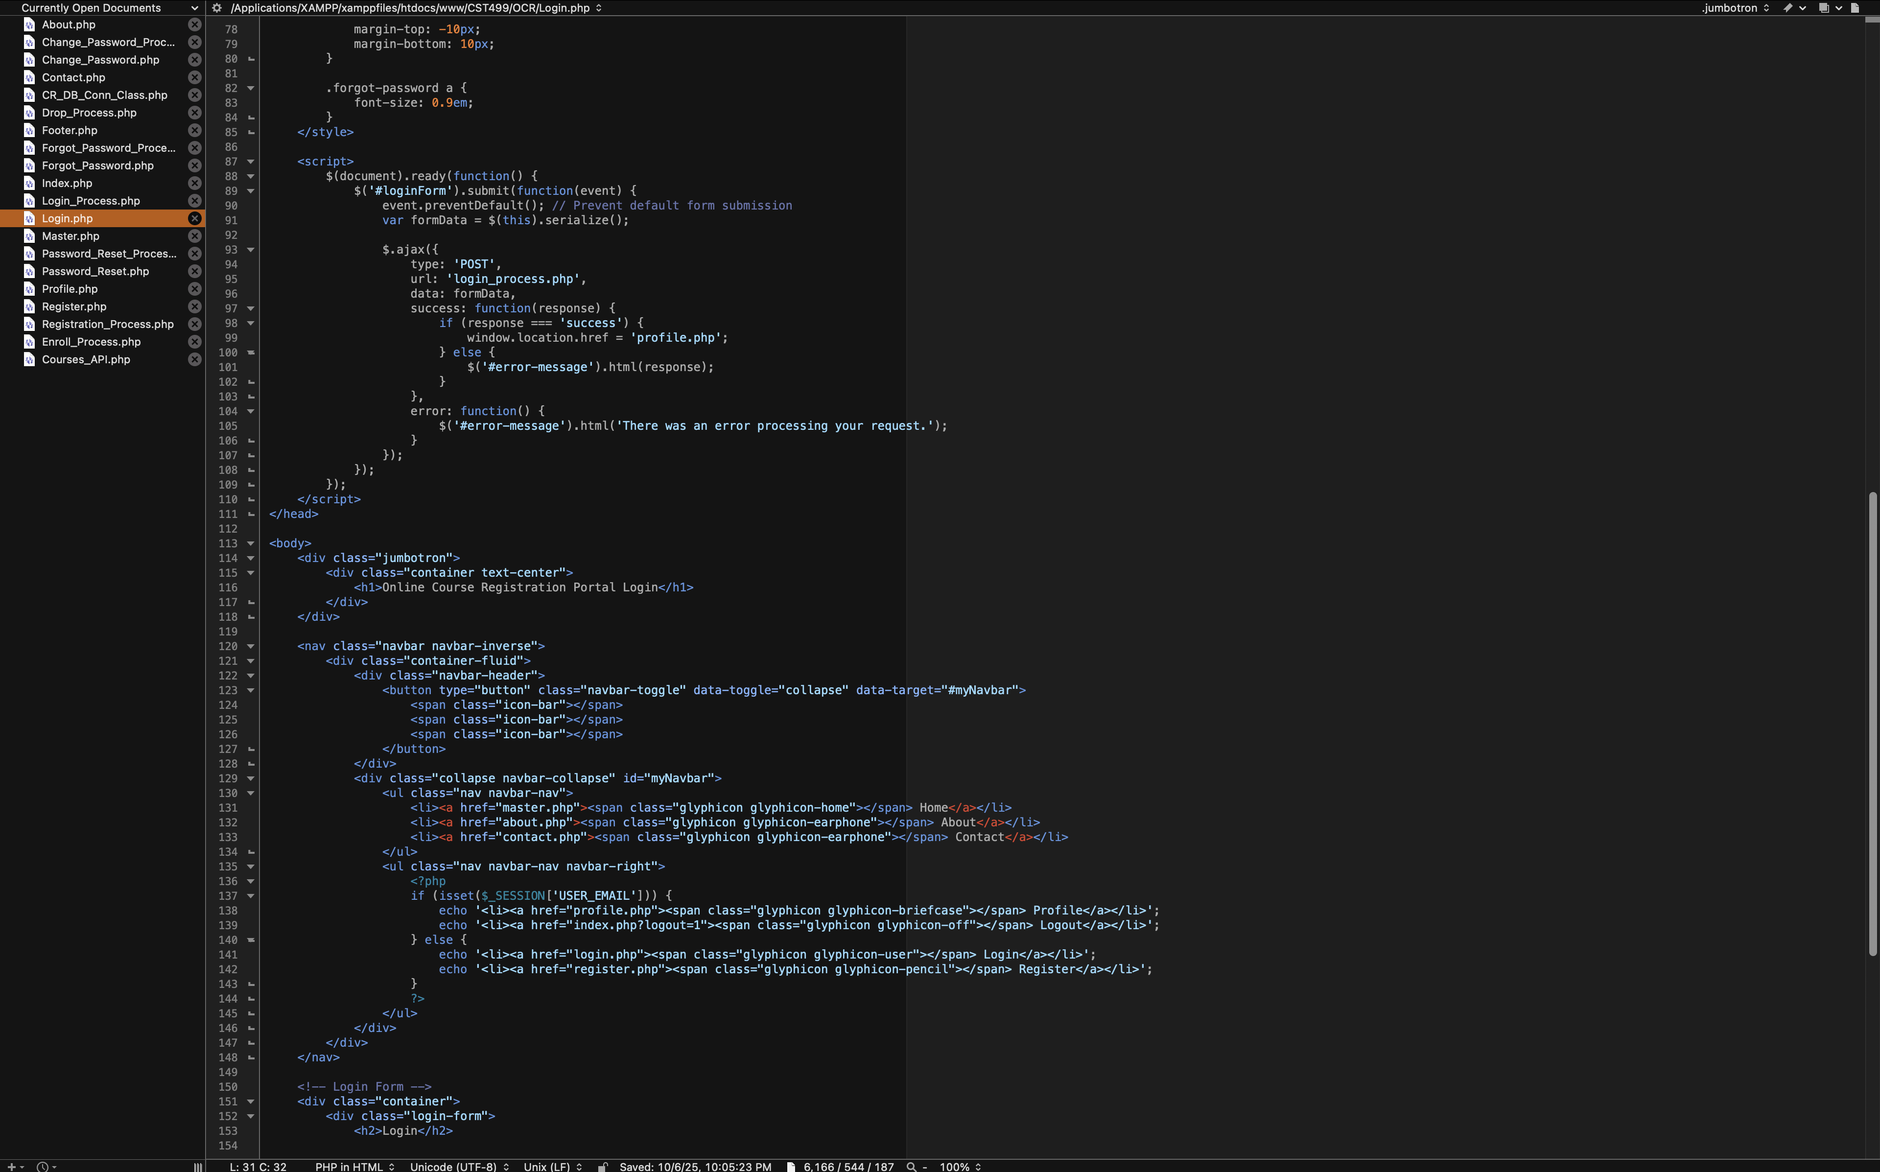

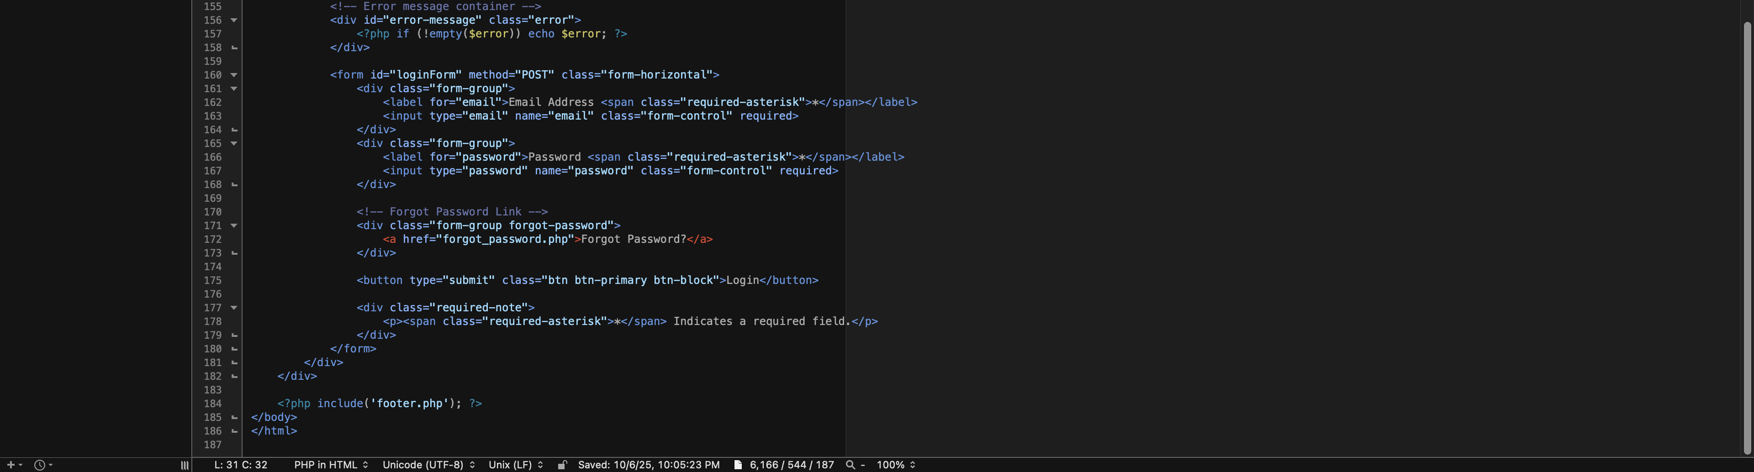

**Login_Process.php**

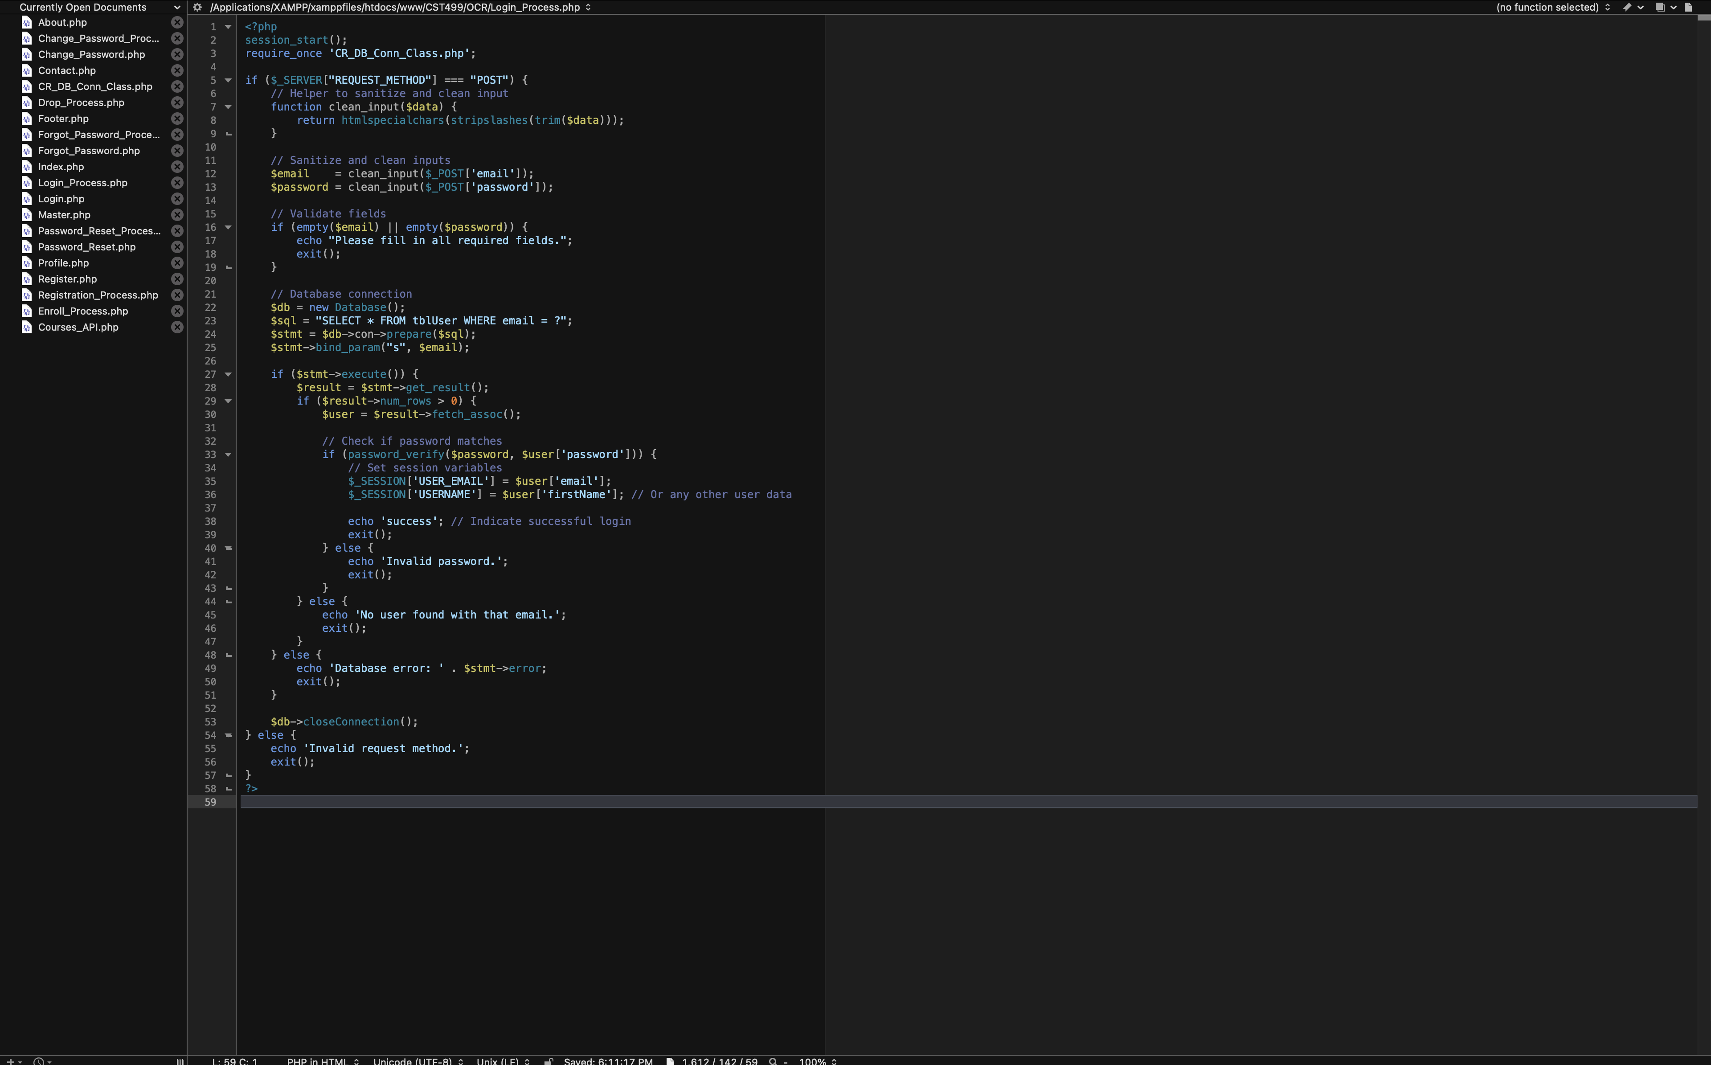

* **User Profile (Profile.php):** Page that displays the profile information of the logged-in user based upon their role (admin or student) in the left panel and the right (main portion) side of the page houses the data to display current courses along with the ability to add, drop, or waitlist courses for the logged in user and term selected by the user. This is done via an AJAX call to the Courses_API.php code behind, which allows for the data to display without reloading, in addition to providing a total number of course credits the user is registered for within a particular term/semester.



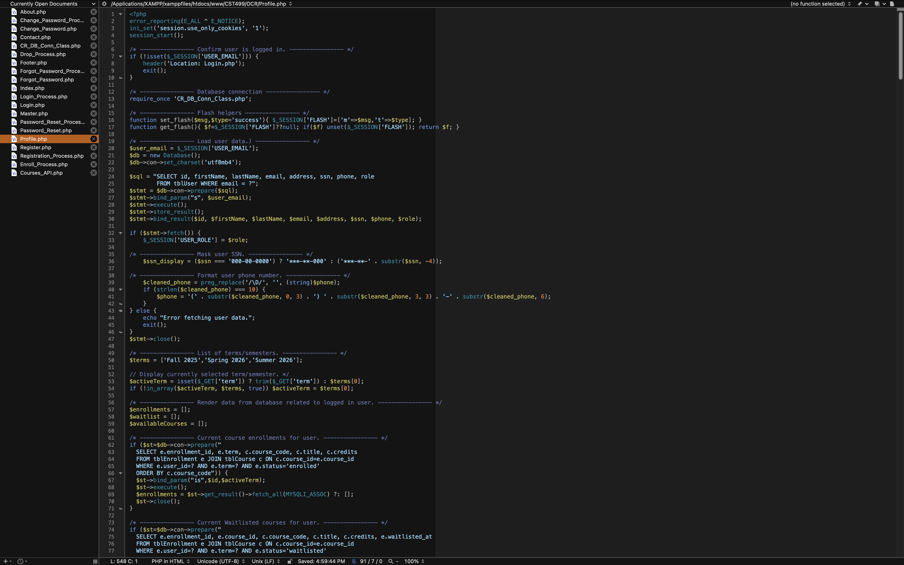

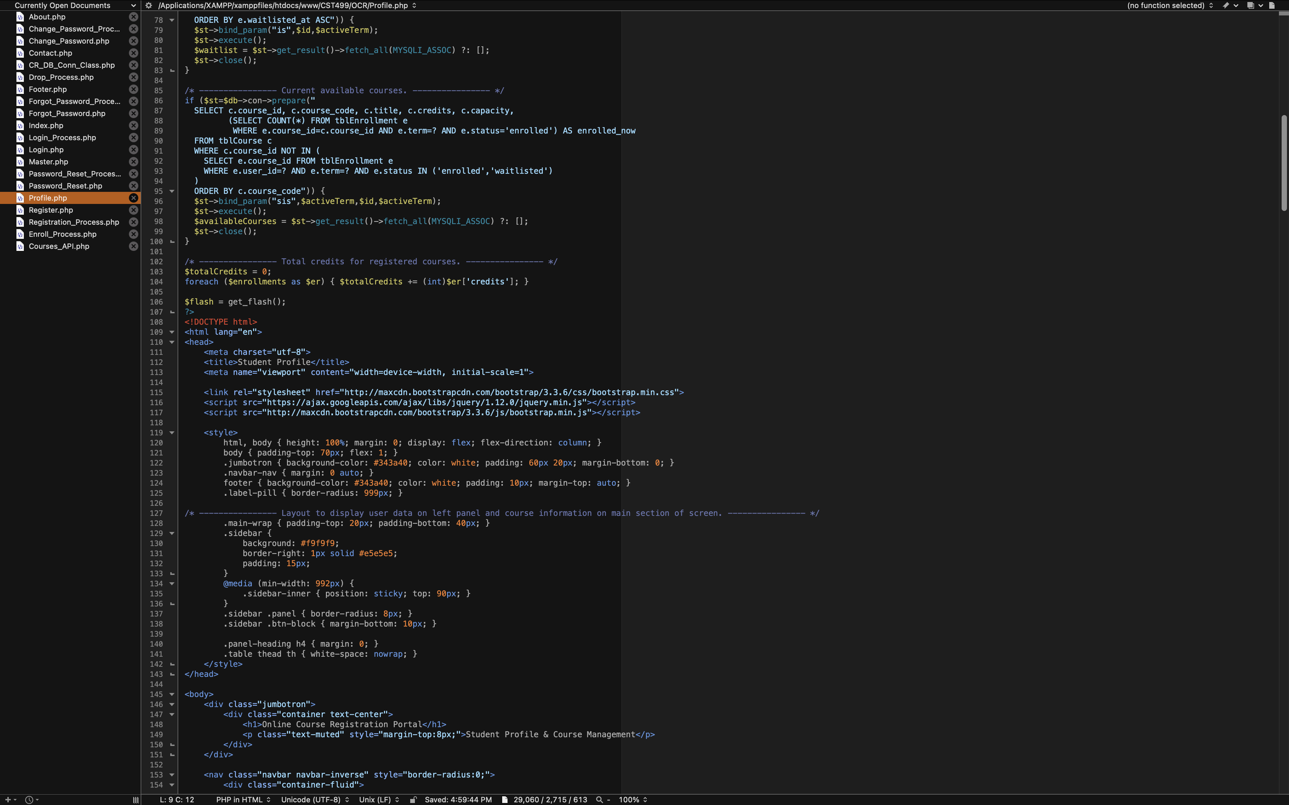

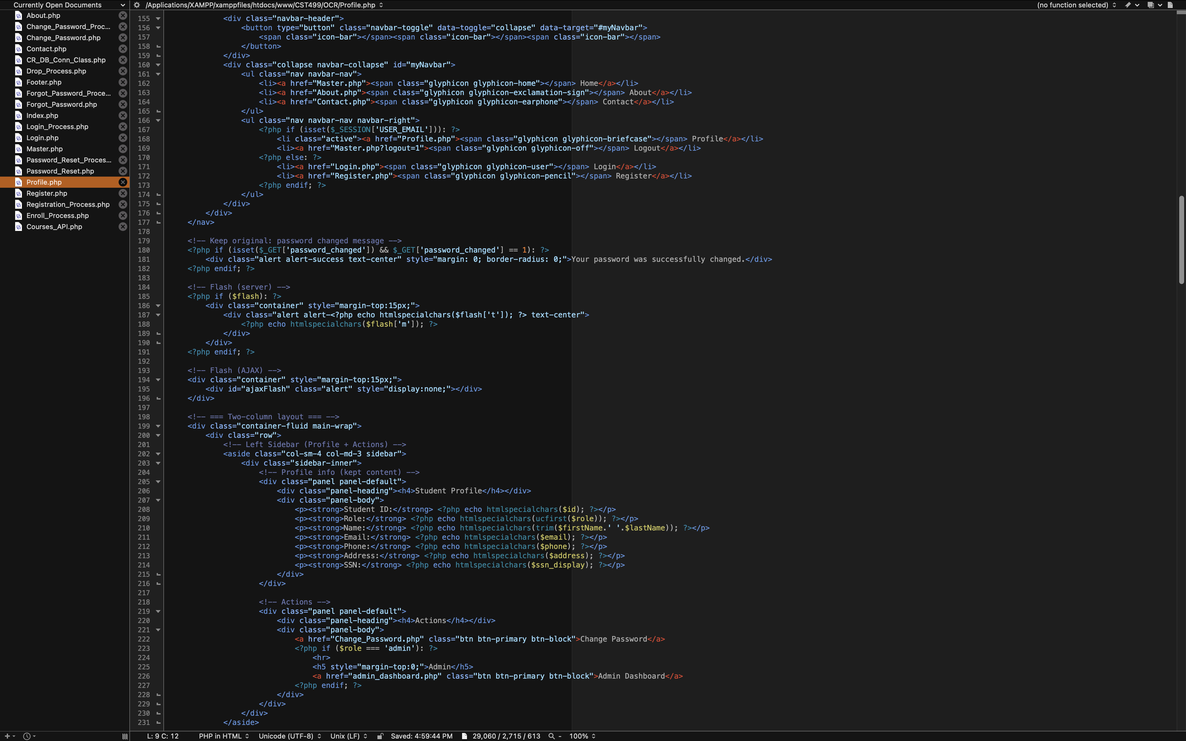

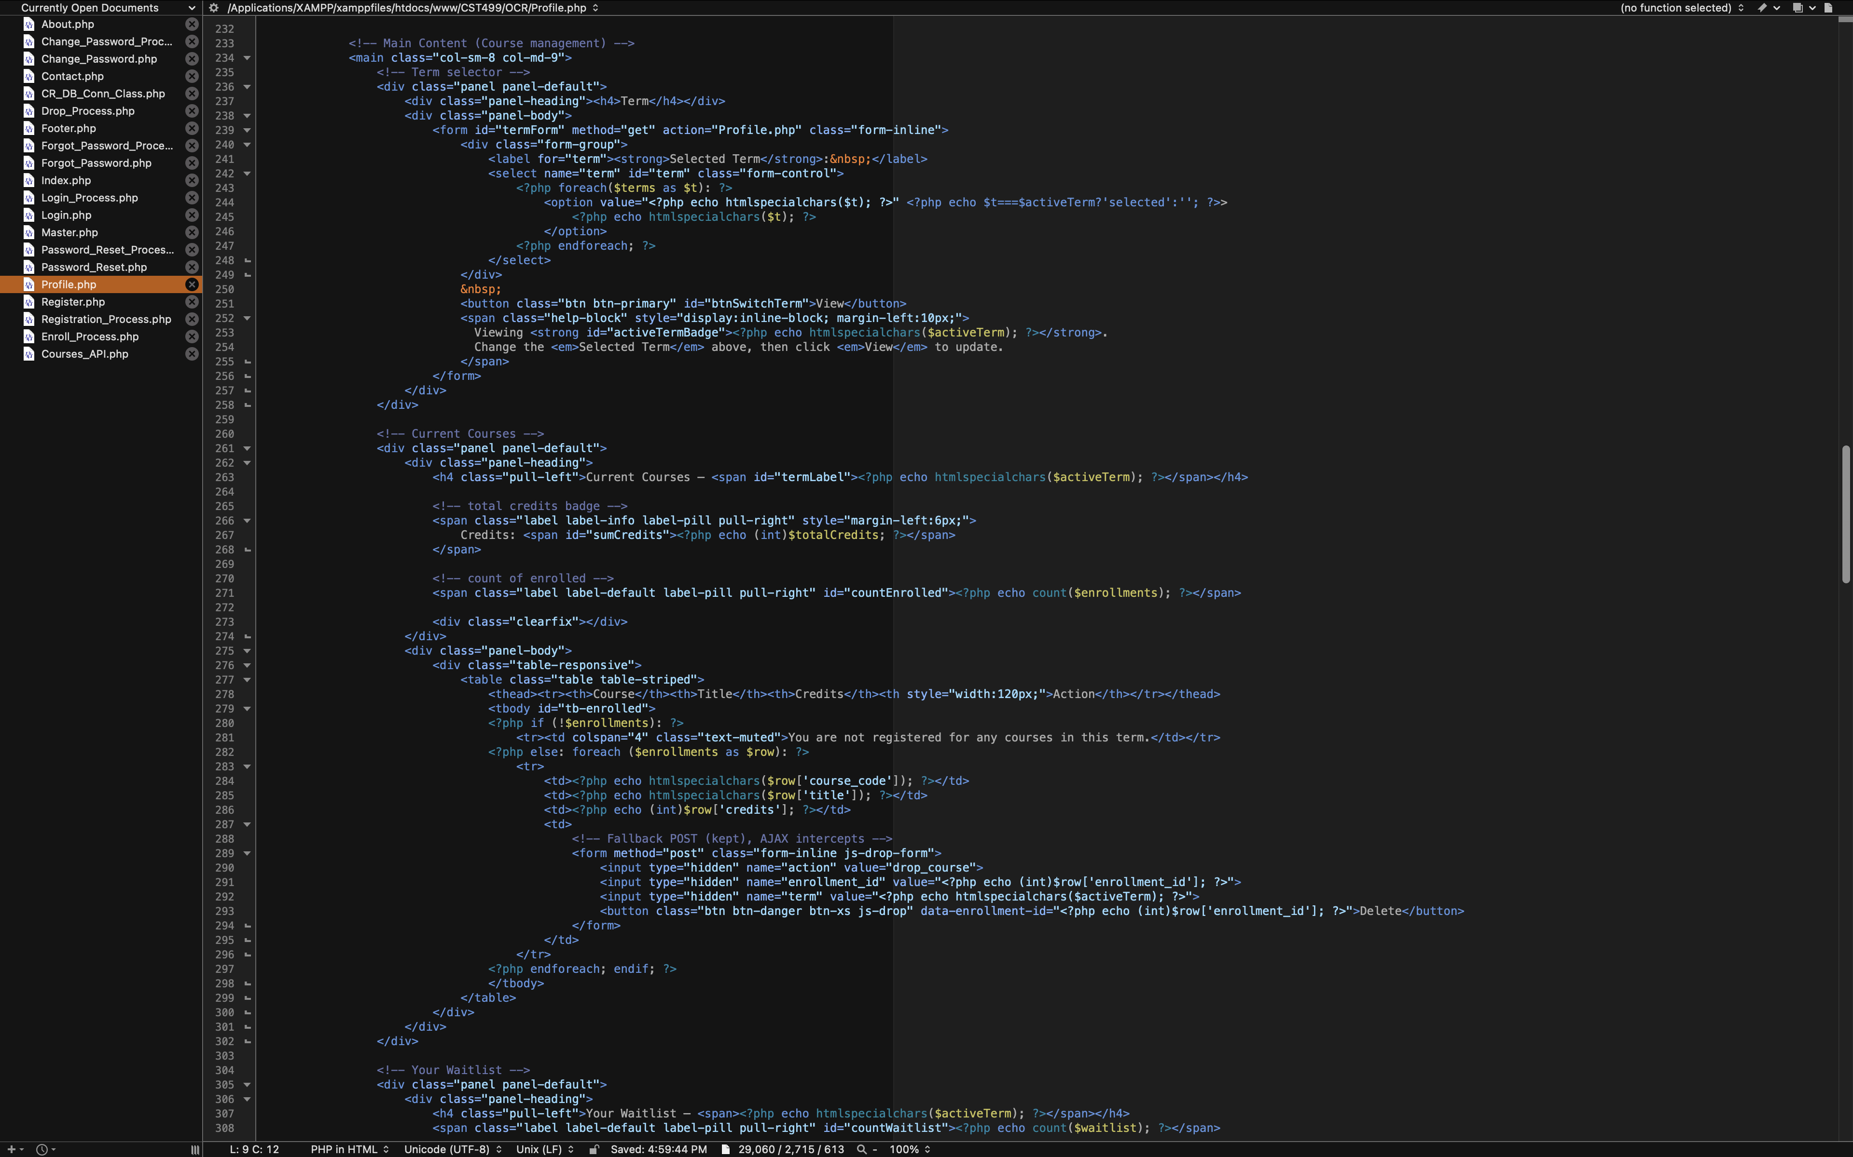

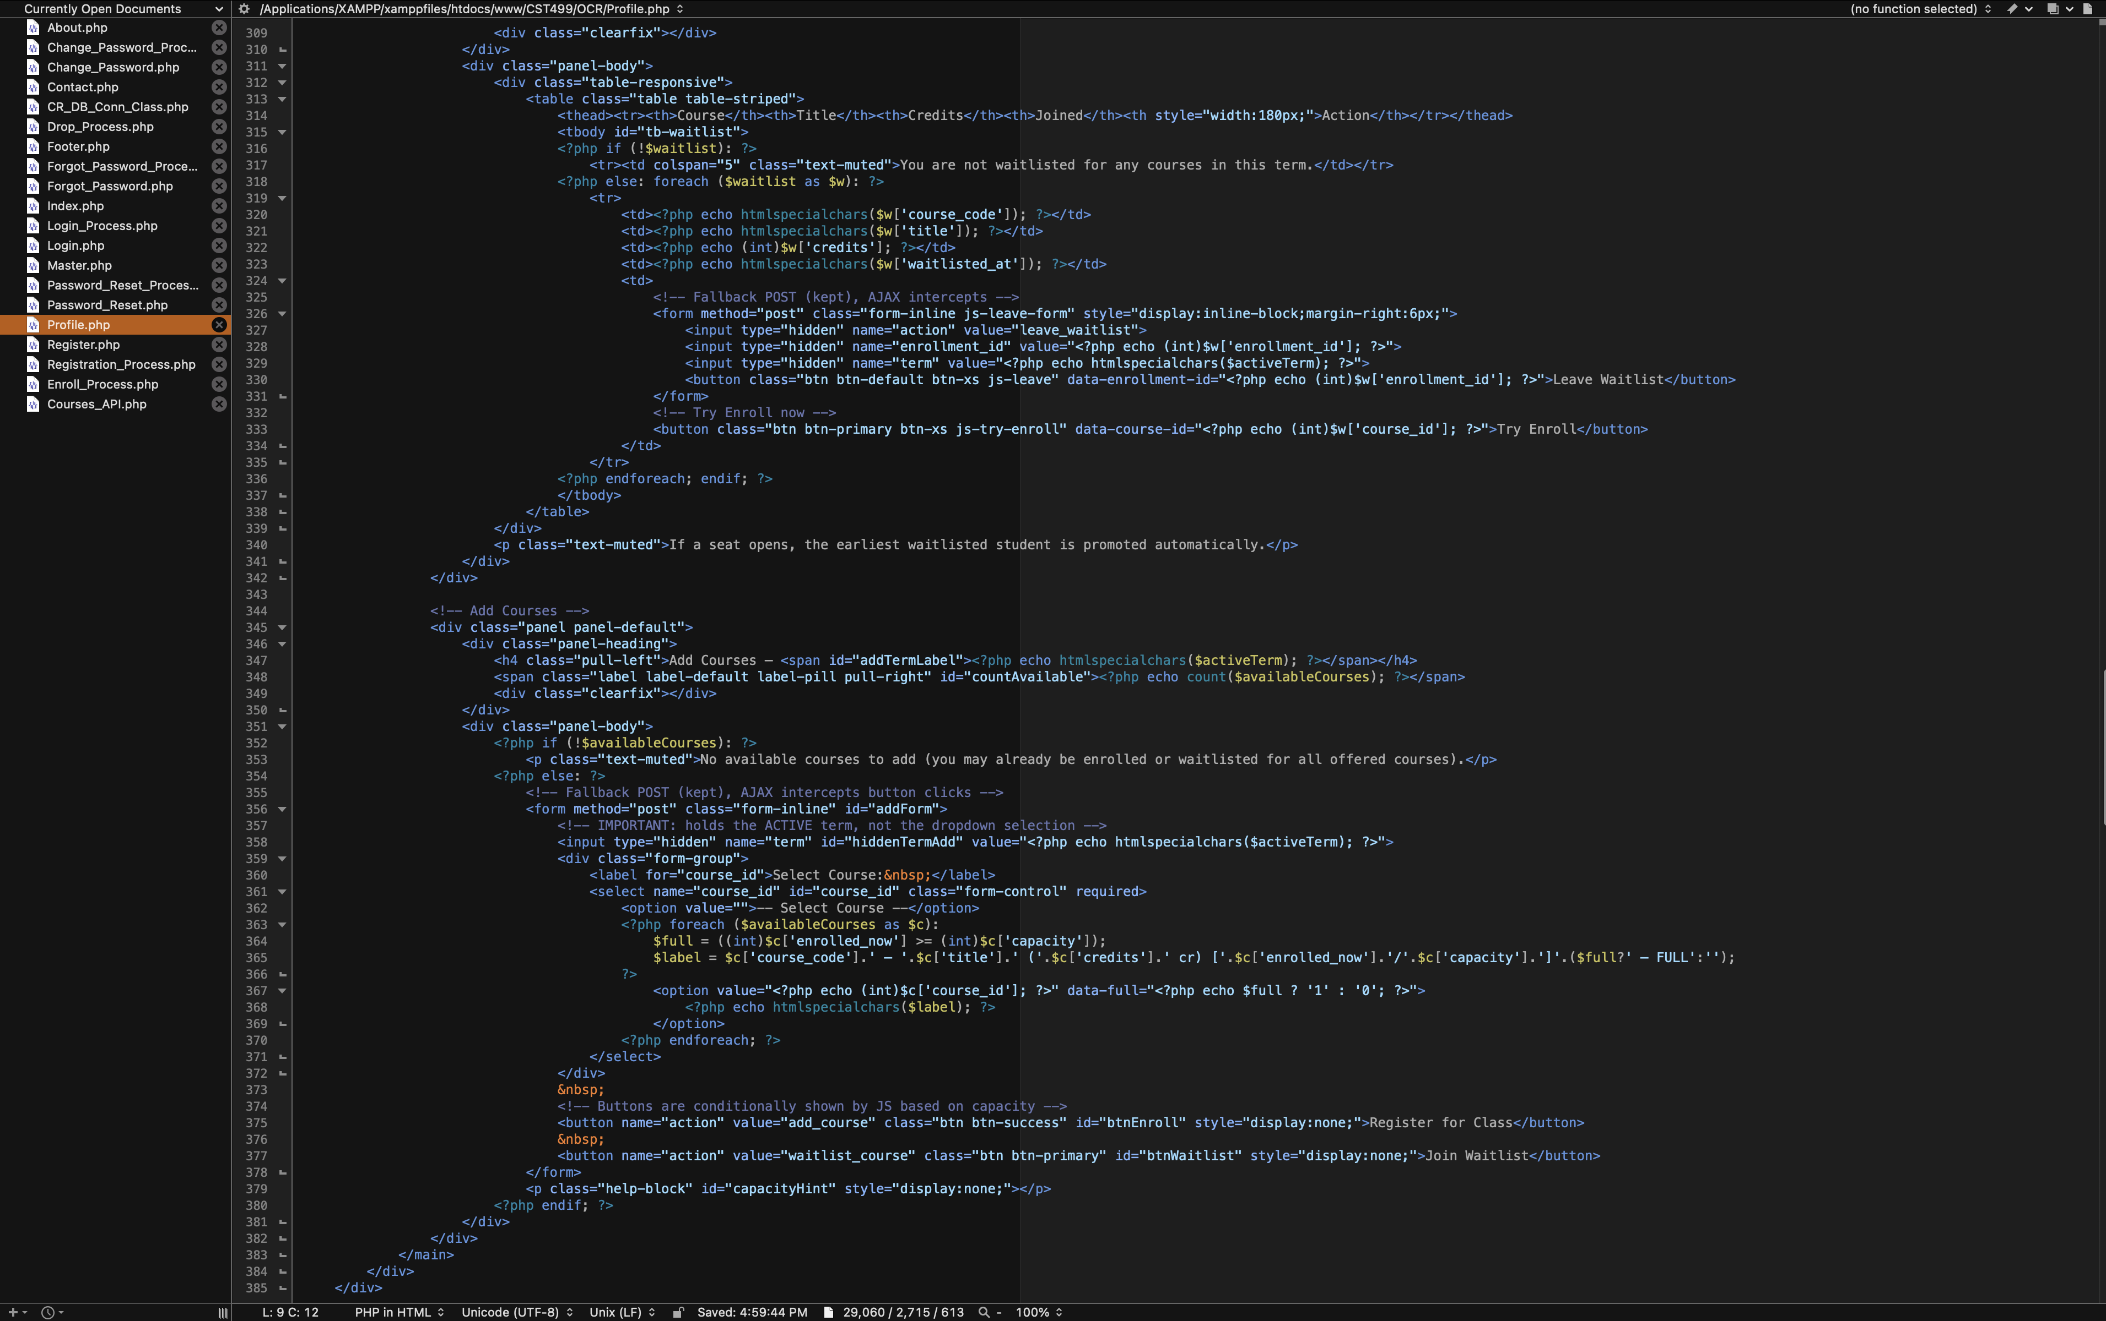

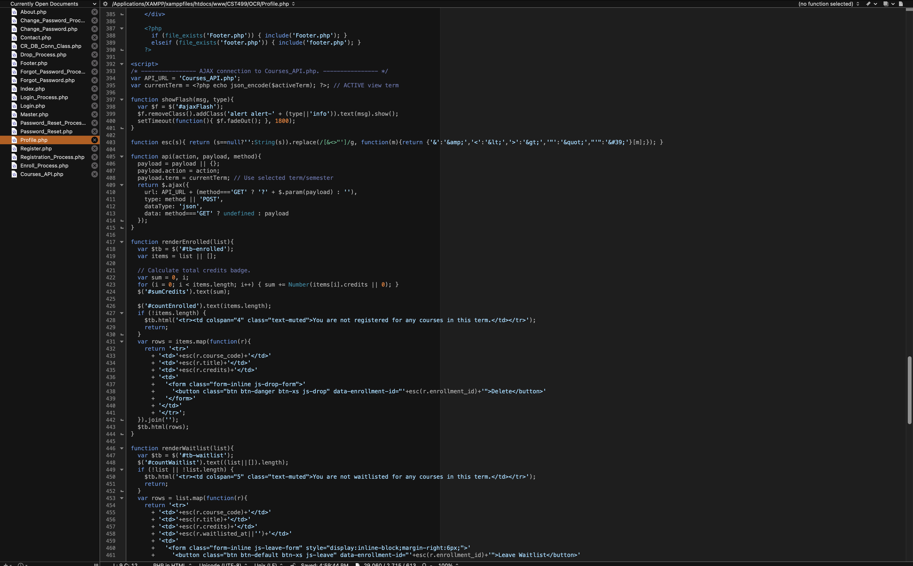

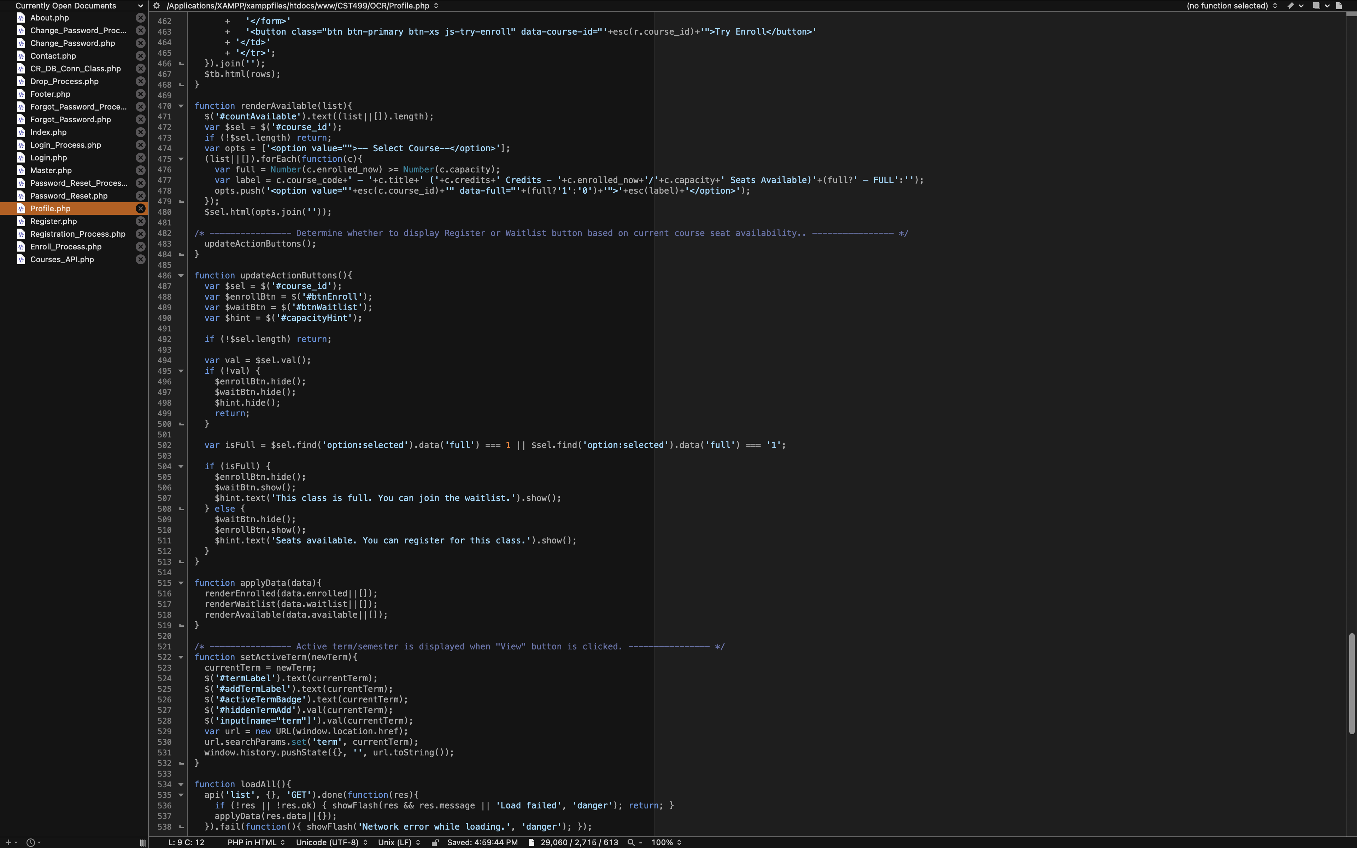

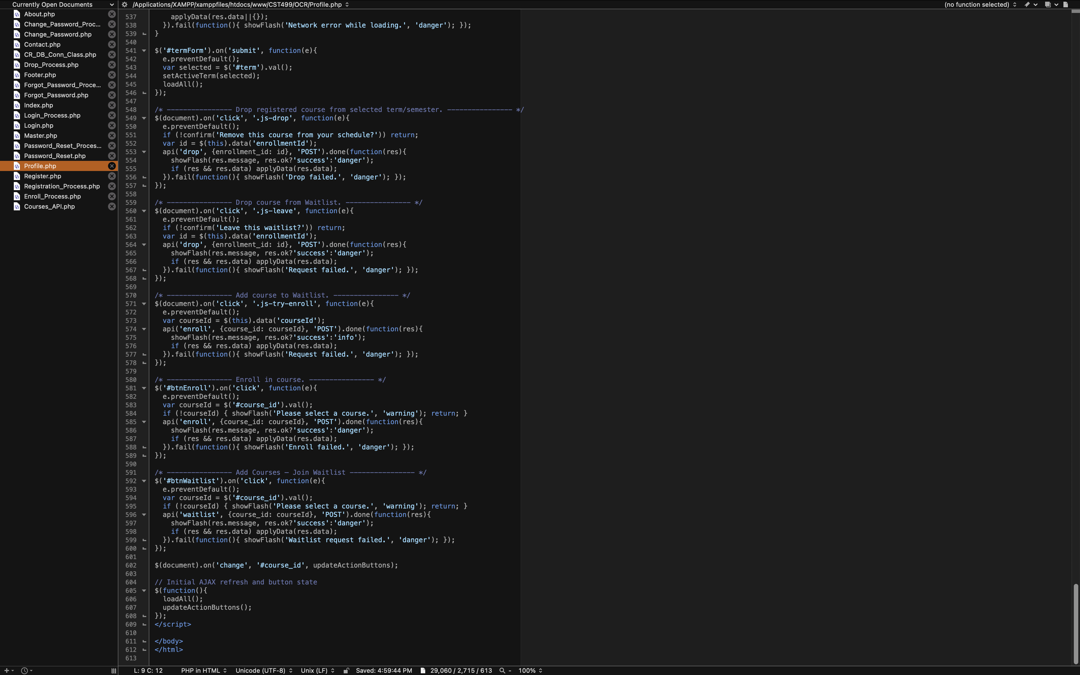

* **Courses_API.php:** JSON API that makes the process for a user to enroll/delete/or waitlist a course seamless. This API connects to the Enrollment table within the database and allows for changes to be made and there is no need to refresh the page after interaction providing the user with live data and a pleasant viewing experience.

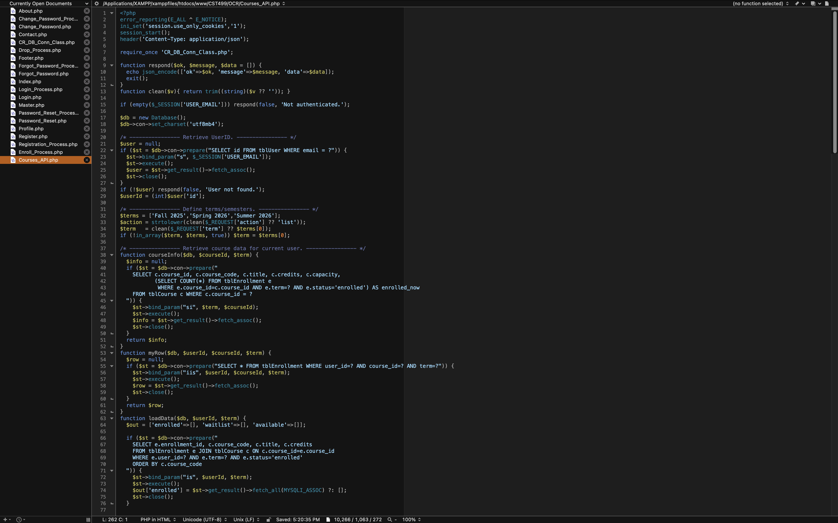

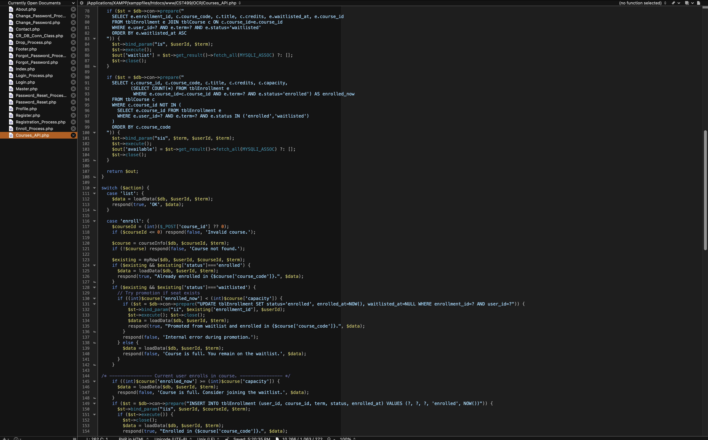

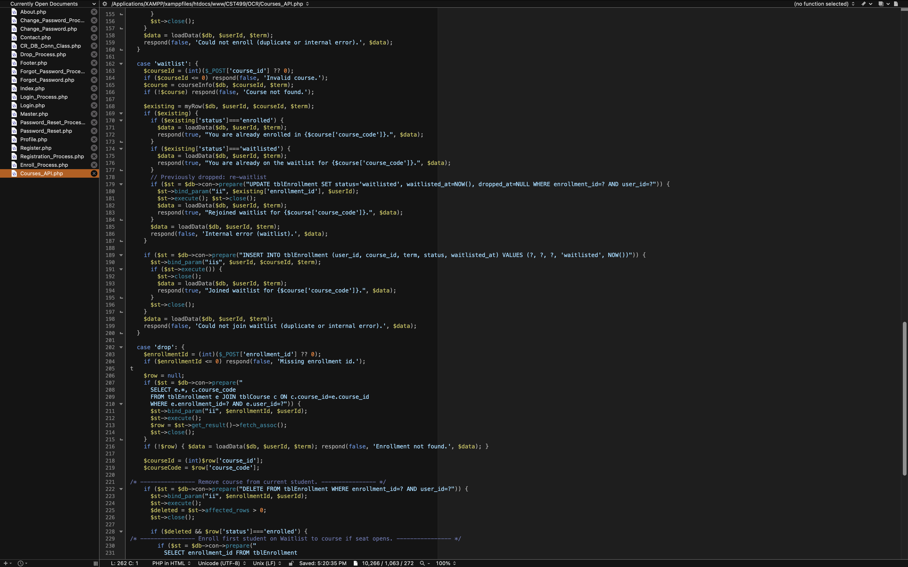

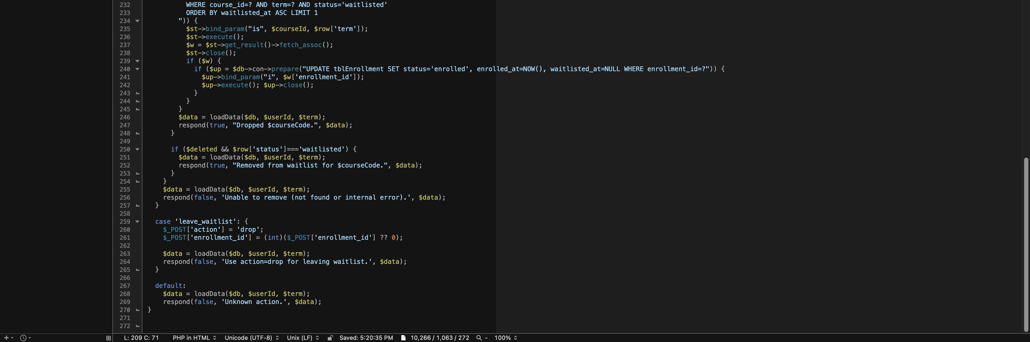

**Capacity-Aware User Experience**

The “Add Courses” panel shows “Register for Class” only when the selected course has seats available and shows “Join Waitlist” only when the class is full. This avoids conflicting calls-to-action and mirrors registrar policies. Additionally, the user can see the number of seats available for all offered courses when they select the course in real time using the AJAX rendering. The number of credits for the particular course, along with the seats available, is displayed with the course ID and course name in the dropdown. This creates a realistic registration workflow that aligns with modern software design practices (Tsui et al., 2018).



**Implementation Experience**

During the implementation process, many lessons were learned; however, three lessons were the most prominent. The first lesson was that the integrity of the schema is important in the aspect that constraints and foreign keys can reduce the number of defects within a class based on how the schema is constructed (Codd, 1970). The second lesson is that using prepared statements with parameter binding not only simplifies code review but also aids in lowering the risk of injection when compared to using ad-hoc statements. The last lesson learned was that using AJAX calls to the API created to complete course registration interactions not only simplifies the process, as everything is handled within one API, versus creating a database connection for each individual interaction. This not only avoids race conditions but is best suited for small and large deployments. By using an API versus separate calls (thus creating a page refresh per interaction), performance is improved and so is the user experience.

**Conclusion**

By centralizing the system to use a normalized schema with required primary and foreign keys in addition to parameterized access patterns and a JSON-based API to render and complete any requested interactions within the user profile page, the OCR system now provides a performance-driven user experience that is not only reliable but also allows for the completion of any necessary actions relating to course registration. Additionally, the user is able to see their course schedule with the number of credits registered per semester. The User Interface reflects real-time course offerings, course capacity powered by backend logic to ensure consistency is present for all users and all interactions. These design and logic choices are in line with a relational model that follows modern and secure coding while providing a maintainable, sustainable, and expandable application with little to no overhead.

**References**

Codd, E. F. (1970). A relational model of data for large shared data banks. *Communications of the ACM*, *13*(6), 377–387. <https://doi.org/10.1145/362384.362685>

MySQL. (2019). *MySQL :: MySQL Documentation*. Mysql.com. <https://dev.mysql.com/doc/>

PHP. (2019). *PHP: Prepared Statements - Manual*. Php.net. <https://www.php.net/manual/en/mysqli.quickstart.prepared-statements.php>

Tsui, F., Karam, O., & Bernal, B. (2018). [Essentials of software engineering](https://uagc.instructure.com/courses/150851/modules/items/7693353) (4th ed.). Jones & Bartlett Learning.

‌